

E-Vehicle Rental System

Junwen Yang, Zheng Zhuang, Chang Yan, Zi Zheng, Bingjie Xu, Hallton Jiao, Hao Xie

School of Computing Science

Sir Alwyn Williams Building

University of Glasgow

G12 8RZ

A dissertation presented in part fulfillment of the requirements of the Degree of Master of Science at the University of Glasgow

**Abstract**

In order to balance environmental protection and increasing traffic pressure, shared transport is becoming a mainstream mode of travel. Users simply scan a code to rent a vehicle and then park it at a designated location to end the rental. Fast, cheap and environmentally friendly is the best synonym for shared transport. This project is an improvement on the more mature software already available on the market. The best thing about it is that it is not only possible to rent bicycles, but also the more convenient electric scooters. The article starts with an introduction to the project, analyses the current context of the product, discusses the product requirements and translates them into a project design. Finally, the project is implemented and tested according to the designed functionality. Although the project is not a mature commercial product, the basic system architecture is well developed. The code is scalable and can be extended to include more features in future tasks.

Acknowledgements

We would like to thank Dr Mireilla Bikanga Ada, Dr MaryEllen Foster and Dr Kevin Bryson for their truli invaluable supervision, guidance and emotional support throughout the project.

We would also like to thank every member of the group for their contribution to this project. This project would not have been possible without the active communication and goodwill of each member.

Contents

Chapter 1 Introduction 2

Chapter 2 Background Survey 4

Chapter 3 Requirements 5

Chapter 4 Design ……………………………………………………………..6  
  
Chapter 5 Implementation 10

Chapter 6 Evaluation 14

Chapter 7 Conclusion 16

References 17

Appendix A < Diagrams required for main text > 19

Appendix B < UI Design>…………………………………………………28

**Appendix C <** **Mobile-end code showcase>…………………………….37**

**Appendix D <** **Back-end code showcase>………………………………42**

**Appendix E <** **Front-end code showcase>……………………………..76**

**Appendix F <** **User Roles & User stories>…………………………….77**

**Appendix G <** **User Module>………………………………………………79**

# Introduction

This chapter introduces the Shared vehicle rental system project, explains the motivation for writing the project and the development functions implemented by the corresponding program, and finally describes the subsequent chapters of this article and their contents.

## Motivation

In today's era of rapid technological development, smartphones are developing rapidly, and the global smartphone market is expanding rapidly at an alarming rate. Consumers are becoming more and more dependent on smartphones, and consumers are also deriving emotional benefits from them, especially psychological comfort[1].

The development and popularization of smartphone technology has changed people's daily life.In terms of travel, the concept of Internet-based shared motor vehicles came into being. People only need to tap a finger to find a shared motor vehicle for use as a means of transportation, which is not only convenient and fast, but also makes reasonable and effective use of idle resources.

By setting up a simulation model with many input parameters, thus evaluating numerous scenarios. A repositioning algorithm is used, as well as the charging scheme employed when using electric vehicles. A preliminary cost analysis was also performed, showing that such a shared motor vehicle system is very competitive with current transportation systems[2].

## Aims

The project aims to create an application that supports the following main features:

user:

• register, login, logout

• View the map (find car rental locations)

• Rent a vehicle, pay for it, return a vehicle

• Damaged Vehicle Report, Select Vehicle Type

• View order, cancel order ()

• Check balance and recharge

• Issue a non-return report (generate a payment order for an additional return)

• Temporary parking application, *Reservation to rent a car at a certain time

operator:

• register log in

• View all vehicle information, view damaged vehicles, view rental information

• Update vehicle information = update vehicle location + update vehicle health

• Create and delete vehicle information (relevant to the application of a new vehicle related to the complete scrapping of the vehicle and cannot be repaired, and a report to the manager)

manager:

• Create users, delete users, view all user information, view all order records

• Generate reports

The main purpose of making this application is to meet the needs of customers for renting shared vehicles. Customers will be able to freely choose the type of vehicle they want to rent and can also select a specific vehicle through real-time positioning on the map. After selecting the vehicle, make payment and generate order data. After the customer uses it, the vehicle is returned, the order is completed, and the vehicle is damaged. When the situation occurs, the customer can give feedback in time and notify the operator to carry out timely maintenance and repair.

## Chapter Structure

This chapter summarizes the motivations and goals for the development of the Shared vehicle rental system. In the following chapters, the development process of Shared vehicle rental system and the specific function implementation will be described. The remaining chapters of the structure are as follows:

• Chapter 2: Background research on three different car-sharing vehicles, features and development of the sharing economy, and also compares the existing applications related to car-sharing in the market and compares them to determine their different characteristics.

• Chapter 3: This chapter provides an overview of the overall process of functional and non-functional requirements analysis.

• Chapter 4 & 5: Will discuss design process methodology by explaining software development, will introduce system architecture, activity flow diagrams for using and building user interfaces, ER diagrams, tools used and specific technical frameworks and some prototyping diagrams such as wireframes , UI diagram

• Chapter 6: Introduces the entire system of the Shared vehicle rental system and various implemented functions.

• Chapter 7: This chapter will evaluate the entire system, including unit testing, user evaluation using surveys and requirements verification.

• Chapter 8: The final chapter will summarize the entire content of this paper and suggest future revisions to address the project's deficiencies

# Background Survey

This chapter will discuss the background research on shared vehicles in the past, divided into three different parts: shared cars, shared electric vehicles, shared bicycles.

## Background research

The sharing economy will inevitably become a major part of the global economy[3]. The development of the sharing economy relies on a powerful Internet platform to keep moving forward.As a representative of the new economic model, the sharing economy has gradually penetrated into every corner of life. As one of the best among them, car sharing has greatly changed people's lives.

### shared bicycles & electric vehicles

In the past, people traveled a distance of about one or two miles, and people traveled by walking, because the distance was short and the bus could not reach the destination, the subway was too expensive, and the walking was too tiring. Now that shared bicycles have entered the market, it has solved the problem of short distances. The convenience of travel, no longer worry about "one or two miles of road" travel.

The number of cities that have introduced and operated bicycle sharing systems has increased significantly over the past few years. These systems provide sustainable transportation for city dwellers. In addition to energy sustainability benefits, bike-sharing systems can have a positive impact on the health of residents, air quality, and the overall health of our currently crumbling road network infrastructure. Anecdotes and research studies also show that bike lanes have a positive impact on local businesses[4].

### Shared Cars

Car sharing is a car rental model for renting a car on a short-term basis, either by the hour or by the mileage. The target of car sharing is generally customers who do not have a car but occasionally need to travel by car. In Italy, the demand for shared cars has grown rapidly in recent years. More than 1.3 million users were registered on the service's website in 2017, of which 800,000 were active users who rented at least once in the past six months. There are 6,600 motor vehicles available and more than 7 million rentals[5].

## Why people use the sharing economy？

The essence of the sharing economy is to integrate unused items in reality and provide products or services at lower prices. For the party who provides the item, a certain remuneration is obtained by providing the right to use the item within a certain time interval; for the customer, it does not enjoy the ownership of the leased item but obtains a certain amount of the item through sharing. right to use within time.

SE has become a buzzword in public media since Botsman and Rogers (2010) published their book on the rise of collaborative consumption[5]. "Sharing economy", "collaborative consumption", "peer-to-peer economy" are the most popular terms used to describe this phenomenon as the peer-to-peer sharing of underused goods and services, prioritizing usage and accessibility ownership (Schor and Fitzmaurice, 2015). However, compared to typical fads, SE presents an opportunity to change the way we understand events by rethinking our business model design and day-to-day decisions, which is both an opportunity and the challenges have far-reaching implications[6].

## 2.3 Existing Related Applications

This chapter introduces and compares three vehicle sharing applications that already have a market share, with different rental models, and then compares the advantages and disadvantages of these rental models in detail.OFO is the world’s first bike sharing platform with non-fixed parking locations (available anytime, anywhere)[7],A detailed app comparison can be found in the appendix A.

## 2.4 Summary

These three existing apps with high market shares are all capable of meeting the needs of consumers for cycling. Each has its own advantages and disadvantages; however, no single app can fully satisfy all consumers' needs.

We therefore decided to design and develop a more complete app based on the analysis of the above three apps, considering their strengths and weaknesses.

# Requirements

This chapter will describe the functional and non-functional requirements of the program's project.

## 3.1 Requirements Flow

The list of requirements needs to be finalized in the following way. First, the group discusses and collects and organizes all ideas to document them. Then, some virtual user portraits are created that are used to describe how different users will interact with the application. These scenarios were then translated into different ways of interaction between the program and the administrator/manager/user.

Subsequently, a first draft of the requirements was created based on the application scenarios and all the requirements were ranked according to importance, discarding some of the less important requirements and keeping the higher priority ones. All requirements were finalized.

## 3.2 Concept

The first step was to conduct relevant background research and record the ideas through group discussions and categorize them into different functions required by different subjects. These functions are the basic functions that are necessary for a shared motor vehicle and include the specific actions needed by the user and the administrator/operator. The group listed multiple ideas.

## 3.3 User Roles & User stories

Considering the need to refine more, we have developed some scenarios to capture the following scenarios rental car users, administrators, and operators with different needs of three subjects, users from different age ranges and different occupations that will interact with the application. For users using shared motor vehicles, the following scenarios have one main goal, to pay and rent a motor vehicle to ride and finally complete the return operation, and these specific operations will be implemented in the developed application. Detailed scenarios can be viewed in the appendix F.

## 3.4 Survey

After creating the user stories, further additions were made to the requirements. Then a questionnaire was released about bike sharing, and the list of requirements that could be implemented in this application was rated for importance based on the results of the survey, and whether to develop the requirement was determined based on the level of importance.

# Design

This chapter will discuss the software engineering processes and practices used throughout the project.

## System Architecture

Like programming languages, teamwork in modern projects is based on an object-oriented and modular working model. The system architecture of this project is therefore based on a three-layer model, namely presentation, application and data layer. The advantage of this design is that each part can be developed individually and in parallel. The prerequisite of course is that the interfaces connecting the various parts need to be defined. When the development of each part is complete, the interfaces can be used to pass data and make the project work. As shown in Figure 4.1: Front and back-end interaction system architecture.

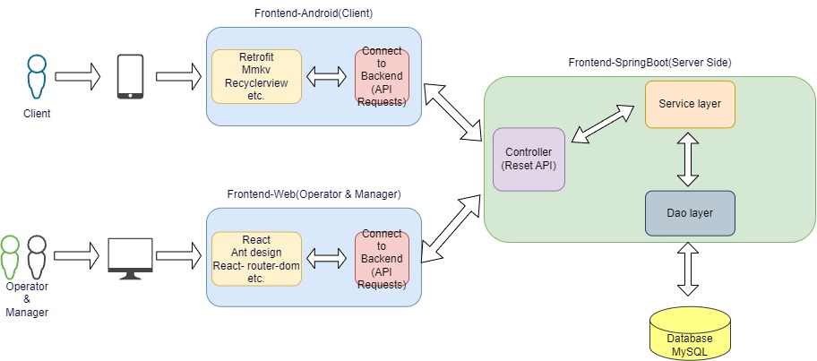

***Figure 4.1:*** *Front and back-end interaction system architecture*

**Presentation layer:** After analysis and discussion of the project requirements, the front-end part should not only be the website from a practical point of view[8]. The reason for this is very simple: most of the time when customers want to hire a vehicle, it happens outdoors. It is essential that an easy-to-use mobile app should be designed for the customer, while the operator and the manager should continue to use the website to do so. Therefore, the front-end part of this project consisted of android and web as shown in Figure 4.1. The technologies used and relied on in the two parts are different. Android application will use retrofit, mmkv and cyclerview, while React will be used as the overall framework in web. This can also be done using various component libraries on top of React. What they all have in common, however, is the need to use a back-end interface to enable data transfer.

**Application layer:** It is like the CPU of a computer, responsible for interpreting the computer's instructions and processing the program's data[9]. For this project, it is responsible for receiving instructions from the front-end, processing the correct data according to the instructions, and finally sending the data back to the front-end to form a closed loop. The entire back-end uses the Spring Boot framework and the automation architecture tool Gradle, which contains three important parts: Controller, Service and Dao. Controller acts as a bridge between the outside and the Service, through which the front-end will pass when calling the interface to access the relevant business. Service holds all the internal business logic, and as the data persistence layer, Dao, is primarily about data transfer with the data layer.

**Data layer:** As you can see from the name, this layer is used to storing the data for the entire project, such as user information, vehicle information, etc. This layer is usually referred to by a database. MySQL has been chosen as the data layer for this project. The design of the database and why MySQL was chosen are shown later in subsections 4.3 and 4.5.

## Use case Diagram

A use case is a methodology used in system analysis to identify, clarify, and organize system requirements. Use case diagrams are employed in UML (Unified Modelling Language), a standard notation for the modelling of real-world objects and systems[10]. In this section, the design of the usage process for this project is presented from the perspective of clients, operators and managers.

**Client vehicle rental use case diagram:** As designed in the previous section, the client's use of the system is based on an Android mobile application. Before clients can log into the system, they need to register accounts. After that, clients can enter their current location directly into the map and the map will show the location of the nearest available rental vehicle to their current location. Besides, they can also select the type of vehicle to find. Then clients can rent a vehicle directly or make a reservation in case it is rented by another client before arriving at the location. For clients who are not using the system for the first time, they can view previous orders. Of course, if clients no longer wish to use the system, they can also cancel accounts. When cancelling the account, the system can refund clients' balance. If they have not paid for the previous order, then they cannot cancel their account.

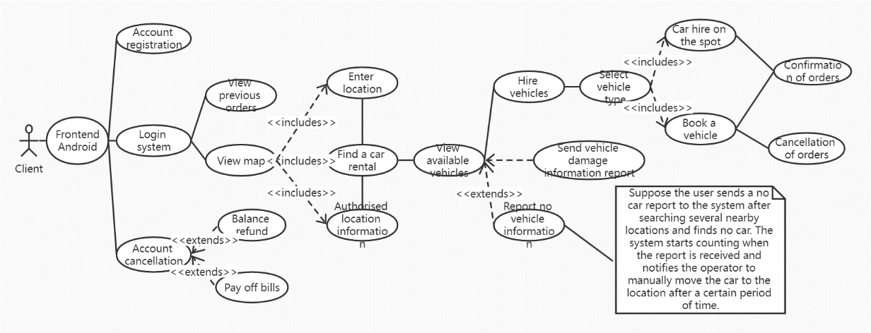

***Figure 4.2:*** *Client vehicle rental use case diagram*

**Client vehicle returning use case diagram:** Because of the impact of the random placement of vehicles on traffic order and the safety of passers-by, many fixed return points have been set up in the system. Clients can search for them in the system's map. If it is inconvenient to park the vehicle at the return point, you can also ask for help. After parking, client need to pay with the balance in the system or top up if the balance is insufficient. In addition, the system also allow clients to suspend the use of the vehicle for a certain period of time without ending the order. However, if the time limit is exceeded, a mandatory deduction will be made. Most importantly, the customer can report to the system if problems arise during the use of the vehicle. As shown in Figure Appendix A.2.1 Client vehicle returning use case diagram.

**Operator use case diagram:** The operator handles the back-office work via the website. The most important task of the operator is to check the vehicle damage reports submitted by clients and to take care of the problematic vehicles in a timely manner. Once processed, the status of the vehicle can be updated. Of course, the operator has access to all the vehicle's information, such as battery level and location. As shown in Figure Appendix A.2.2 Operator use case diagram.

**Manager use case diagram:** The manager works via the website, as does the operator. Manager has the power to create and delete operator accounts. It is also possible to block and unblock the accounts of customers who do not pay on time. Manager can also generate a visual report that allows a visual overview of vehicle usage. As shown in Figure Appendix A.2.3 Manager use case diagram.

## ER Diagram

The database in this project has a total of 5 tables, which are shown in the diagram below[11]. The user and vehicle represent information about all users using the system and all registered vehicles respectively. These two tables are the two most central tables in the system. The balance table is responsible for the wallet function in the system, such as payments and top-ups, and is the simplest of all the tables. The tickets table and the orders table were designed according to the needs of the project. The former stores vehicle reports. This is where any vehicle damage reports that are fed into the system by the customer are stored. The latter stores all the order information in the system and the final visual reports generated by the manager are mainly provided by the information in these two tables. As shown in Figure Appendix A.2.4 ER diagram.

## Prototypes

#### 4.4.1 Prototyping on Paper

Prototyping on paper refers to a common design method used by UX/UI designers to present design ideas through paper, pen, and other office tools[12]. It is a process of creating a digital product on paper with pen and paper. In layman's terms, it is a process in which designers draw various web or mobile application components on paper, complete a preliminary prototype design, and test whether the design concept is feasible and applicable. Therefore, it is also an important way for designers to build prototypes and get feedback on the usefulness of their designs as soon as possible. As shown in Figure Appendix A.2.5 Prototypes.

#### 4.4.2 Wireframe Diagram

A wireframe is a two-dimensional skeleton outline of a web page or application that clearly outlines the page structure, layout, information architecture, user flow, functionality, and expected behavior[13]. Since wireframes usually represent the initial product concept, styles, colors, and graphics are kept to a minimum. Wireframes can be drawn by hand or created digitally in software, depending on how much detail is needed.As shown in Figure Appendix A.2.6 Wireframe Diagram.

#### 4.4.3 UI diagram

UI is short for UserInterface, and UI design is the overall design of the software's human-computer interaction, operating logic, and interface aesthetics. A good UI design is not only to make the software individual and tasteful, but also to make the operation of the software comfortable, simple, and free, fully reflecting the positioning and characteristics of the software.As shown in Figure Appendix A.2.7 UI diagram.

## Tools and Technologies

There are a number of tools and techniques that can be used to build an online vehicle hire web application and Android application. After extensive research, the advantages and disadvantages as well as the limitations of some of the technologies that may affect the implementation of Shared Vehicle Rental System were identified. These resulted in the selection of Gradle Spring Boot for the back end, React with Ant Design UI Component library as a front-end as well as MySQL for the database.

### Backend – Gradle Spring Boot

Before discussing Spring Boot, it is necessary to analyze why Gradle is used instead of Maven[14]. Gradle and Maven are both excellent tools for automating project builds.Maven is now the industry standard, while Gradle is a latecomer, but is on the verge of replacing Maven. There are two reasons for using Gradle in this project. Firstly, Gradle does away with Maven's cumbersome XML-based configuration. XML is known to be a poor reading experience, and although it is easy for machines to recognize, it is, after all, maintained by humans. Instead, Gradle uses the domain-specific language Groovy configuration, which greatly simplifies the number of lines of build code and makes the entire project configuration much more concise and easier to understand.

### Frontend – React & Ant Design

React is a JavaScript library for creating user interfaces, open sourced by Facebook, and is now used in Facebook and its Instagram app. React differs from the huge AngularJS in that it focuses only on the V, or view, of the MVC framework. This makes it easy to integrate React with a developer's existing development stack. When using React, programmers should abstract the different components from the UI and then put them together. It follows the trend of componentization in web development [15].

### Database – MySQL

Compared to other database systems, MySQL has four main advantages[16]. Firstly, MySQL is not perfect, yet flexible enough to adapt to demanding environments. It is well suited to web-based applications. Secondly, MySQL can be embedded into applications as well as supporting data warehouses, content indexing and deployment software, highly available redundant systems, online transaction processing systems and other types of applications. Thirdly, it can be configured so that it runs well on different hardware and can also support many different data types. Fourthly, and most importantly, the most important and distinctive feature of MySQL is its storage engine architecture, which is designed to separate Query Processing and other system tasks from data storage/extraction.

# Implementation

This chapter will specifically describe the implementation of the key features in the rental car application.

Project deployment URL: <https://20.68.139.52>

Demonstration video: <https://youtu.be/e7q3-wBHtWk>

## 5.1 User Module

**5.1.1 Registration and Login Module**

From the background research section, users can use the app more easily after registering and logging in. The project aims to create an application that can be used by the users.The login module uses Singleton Design Mode, which ensures the uniqueness of the account in the application. Meanwhile, in the process of sign in and registration, the application uses the tool of Retrofit, which replaces the OkHttp. The SharedPreference is used to record the login status.

**5.1.2 Vehicle Selection Module**

First, the data of various types of vehicles are accurately displayed on the map through positioning, and users can freely choose the vehicle and the specific vehicle, and then they can rent the vehicle after choosing the specific vehicle and return the vehicle after riding to the location specified by the user.The application through the time stamp to record the vehicle rent and return time, which convenient the back end to maintain data in database. What’s more, Google Map SDK is also used in APP, the interfaces in SDK help to find the longitude and latitude of vehicles. Users need to turn on the camera to scan the QRcode on the vehicle, every QRcode has a SN code to identify the vehicle.

**5.1.3 Payment Module**

After logging in, users can top up their wallets, check their balances, and make payments directly when placing orders. The Wallet module provides the user with a recharge function, this function binding the observer Mode, while user finish their rental, the money in the wallet would be deducted.

**5.1.4 Faulty vehicle reporting module**

If a user finds a damaged vehicle in the middle of the process of finding and renting it, he/she can report it in the application and describe the specific cause of the failure so that the operator can repair it.

**5.1.5 Order Module**

Past order information will be saved, and the user will be able to view past orders and ongoing orders, and if the user mistakenly does so, the user can also cancel the order operation for ongoing orders within a specified time period.

**5.1.6 User information module**

Users can check and update their information in this module, the information of user is from Sington model’s instance.

## 5.2 Operator Module

This part was completed with React, including modules like antd, react-router-dom, css, axios and so on. Some specific techniques will be introduced in related parts.

**5.2.1 Trace all Vehicles Modules**

For an operator, it is essential to access all vehicles in a city, google map here is used to trace all vehicles by showing as red points (here is an example). By clicking the red point, some details will be shown upon the point. In the left menu, operators are allowed to select different kinds of vehicles or all kinds of them. And on the map, operators can drag the “human” signature into the map to see the real environment around the vehicle represented by the red point, which will be helpful to accurately find the vehicle. To complete this function, apart from the mentioned modules, google-maps-react package is used to access Google APIs for JavaScript.

**5.2.2 View Information Module**

Secondly, the operator can view all the existing vehicle information, like viewing the current position of a vehicle or the problem reported by users about this vehicle, viewing battery condition and as well as the status of a vehicle, which helps operators manage, repair, charge vehicles easily. Table of vehicle information is generated by data obtaining from server, with help from Axios tools.

**5.2.3 Update Information Module**

After repairing the vehicle, the operator can update the vehicle information, such as updating the vehicle location and updating the vehicle health status. To do this, the operator needs to click “update” button in “operation” column and then fill the form with the current situation of this vehicle. After clicking “OK” button, new information will be sent to server, with APIs supported by server in next picture. Form is used to check and submit the input of new vehicle situations by some validation functions.

**5.2.4 Update Information Module**

Operator can also add a new vehicle via in update page by clicking “add a new vehicle” button and submitting some details.

## 5.3 Manager Module

**5.3.1 Reporting Module**

This module gives the manager a variety of displays of data records, so that managers can summarize the data to form reports and eventually generate documents for management purposes.

In order to facilitate the display of data, our frontend layout uses the basic ‘top-centre-bottom’ layout. The up-and-down structure is in line with the user's browsing habits, and is also a more classic website navigation model. The next step is to put in some charts and data. Managers need to look at the vehicle activities and visualized data, so it’s essential to give some presentation types. As echarts-for-react has already have many components included in the node-modules, we import bar charts、line charts and pie charts for different aspects of activities. Graph 5.14 shows the different status of two types of vehicles. In order to better summaries the vehicle status and more clearly distinguish between statistics, we combine ‘under maintance’ status with ‘stand by’ status as ’StandBy’, ‘in use’ and ‘stopped by’ status as ‘Used’, ‘defected’ and ‘repaired’ status as ‘Defected’. These data are returned by posting a request to the API /vehicle/find, the API returns all the vehicle information such as status and battery, and the program counts the times of each status and sends the data to the bar chart.

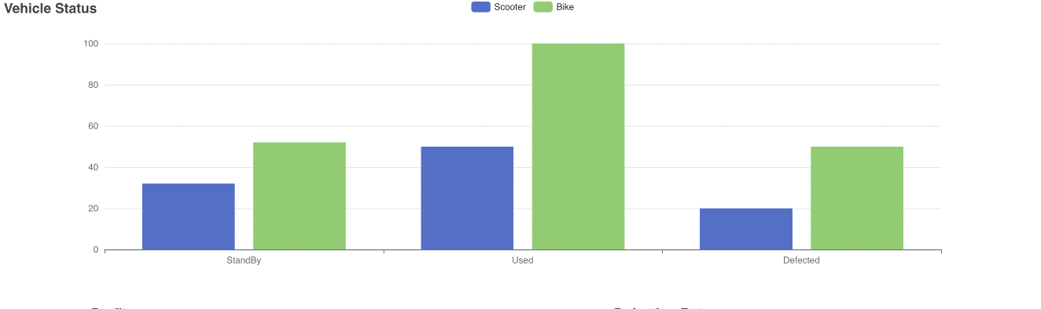

Graph 5.1 Bar chart 1

Graph 5.15 illustrates the use time distribution of two vehicles. Collecting and analyzing the vehicle duration indicates the frequency of usage and tells the managers to better adjust human and vehicle resources. The program gets the data from backend API /order/get/all, the API provides values and data including vehicle using time and fee. The time period is divided into every 5 minutes. Considering both vehicles' usage scenario, data which show use time over 30 minutes are integrated and displayed together.

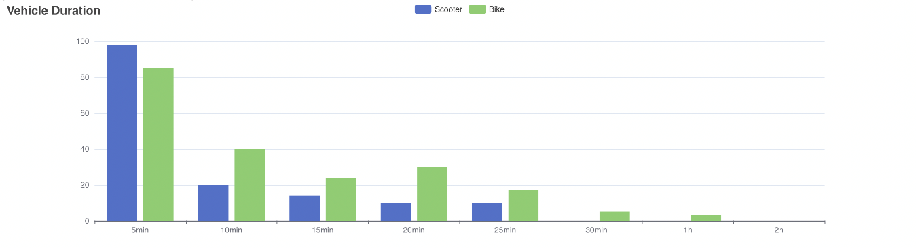Graph 5.2 Bar chart 2

Graph 5.16 shows the profit of vehicles and the defection rate of them. The program gets the money of each order from backend API /order/get/all and calculates the profits. In the meantime, the program gets the defection value from data in ‘Status’ chart and compares the defection rate of both types. In the charts, the two types can be compared in different aspects clearly and the managers have the ability to evaluate the two vehicles and eventually make future decisions. 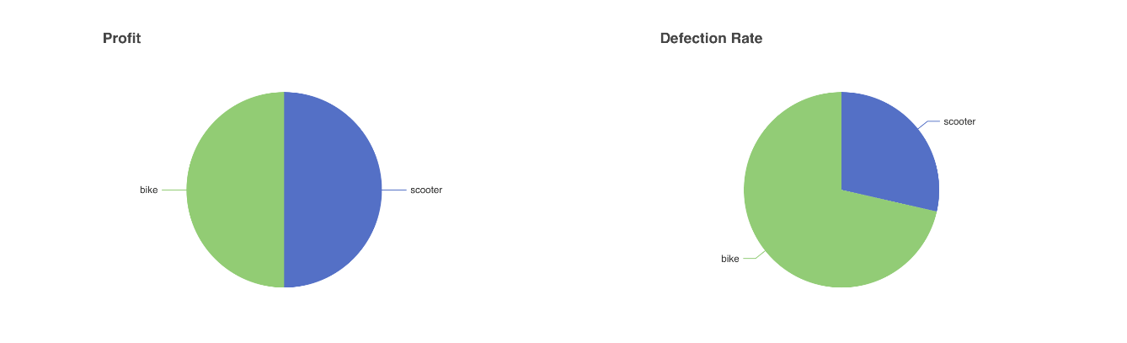

Graph 5.3 Pie charts

Graph 5.17 intends to show which time users use the vehicles more frequently and which type is more popular at different time. The program collects the startTime field from the API /order/get/all and counts the times. The horizontal axis shows the time period in a day. And the vertical axis gives the times of usage.

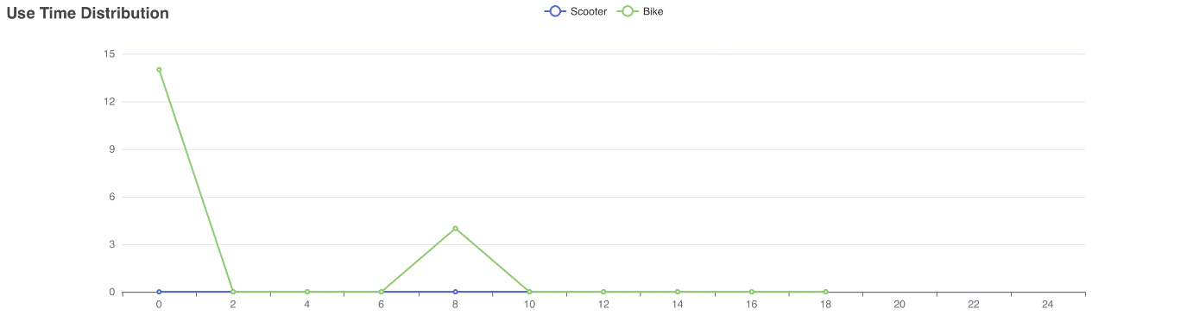Graph 5.4 Line charts

In order to look at the data in different time periods, a date picker is inserted into the page for the managers to select a time period. The program gets the selected time period and send it to all the chart components through one-way data flow of React. The charts receive and display the data in certain time periods.

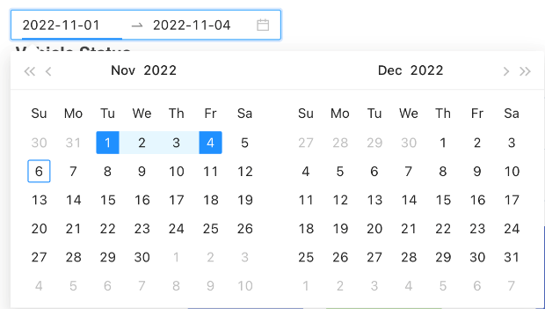

Graph 5.5

The general interface for manager is displayed as Graph 5.19.

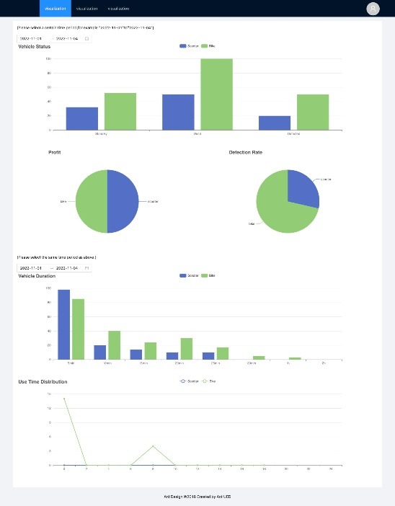

Graph 5.6

# Evaluation

This chapter tests the functions in the system and shows the tested functions and the test results in the table below.

|  |  |  |  |
| --- | --- | --- | --- |
| TEST | DESCRIPTION / ACTION | EXPECTED RESULT | ACTUAL RESULT |
| USER |  |  |  |
| REGISTRATION | Customers register a new account by entering their email, password and avatar picture. | Insert and initialise data in the "user" and "balance" tables of the database. | As expected, passed. |
| LOGIN | Customers log in to the system by entering their email and password. | The system will check that the data saved in the database matches the data entered by the customer. | As expected, passed. |
| VEHICLE SELECTION & RENTAL | The customer selects the type of vehicle they wish to hire in the interface and then proceeds to hire the vehicle. | Showing all the types of vehicles available for hire for customers to choose and hire | As expected, passed. |
| PAYMENT & TOPUP | Customers can top up in the wallet interface. Payment is made when the vehicle hire is complete. | After completing the top-up and debit, the customer's balance in the database changes accordingly. | As expected, passed. |
| REPORTING VEHICLE DAMAGE | Customers can report problems with the vehicle during or after using. | Customers submits a report to the system and operators receives the report information. | As expected, passed. |
| VIEWING ORDER | Customers can view records of previous orders. | Return of previous order data, such as time and cost, etc. | As expected, passed. |
| VIEWING USER INFORMATION | Customers can view their personal information. | Returns personal information about the customer, such as name, balance and avatar photo, etc. | As expected, passed. |
| OPERATOR |  |  |  |
| TRACING ALL VEHICLES | Operators can view the location information of all vehicles. | Returns the latitude and longitude information for all vehicles. | As expected, passed. |
| VIEWING VEHICLE INFORMATION | Operators can view information on all vehicles. | Returns information about the vehicle, such as battery level and usage status, etc. | As expected, passed. |
| UPDATE VEHICLE INFORMATION | Operators can update the vehicle's information manually. | Operators updates the vehicle information and updates the new information into the database. | As expected, passed. |
| MANAGER |  |  |  |
| GENARATING REPORT | Administrators can generate various visual reports to view information about the system. | Using information from various tables in the database, the data is returned visually. | As expected, passed. |

# Conclusion

This chapter will summarize all the chapters in this paper to complete the shared motor vehicle application project.

## 7.1 Summary

The report begins with an introduction to the project, explaining the relevance of its existence and its commercial value. This is followed by a description of the background to the project, as well as pointing out research that has been done on other software systems of the same type. It also discusses the actual needs of the potential users of the system, translating them into the project objectives to be achieved by the system. Based on these requirements, a design solution and specific implementation details for the project are shown. Finally, the entire project was realized and tested according to the design solution. The project basically completes all the functionality needed. The code is clearly structured, and the functionality is logically rigorous.

## 7.2 Future work

Firstly, the payment part of the project is simulated in code, in other words, the customer can top up as much as they want after registering their account and logging in. To make this a truly profitable project, the first thing to do is to implement the interface to the various bank cards and payment institutions in the code.

The second is the security of the project. Rather fortunately, the task of encrypting the user's login password has been implemented. Of course, this is nothing for a professional hacker. So, the other thing that needs to be done for this project is to ensure that the user's personal privacy is not compromised. It is important to ensure that the security system of the whole system is strong enough not to be breached by hackers.

# References

[1] Melumad, S., & Pham, M. T. (2020). The smartphone as a pacifying technology. Journal of Consumer Research, 47(2), 237-255.

[2] Barth, M., & Todd, M. (1999). Simulation model performance analysis of a multiple station shared vehicle system. Transportation Research Part C: Emerging Technologies, 7(4), 237-259.

[3] Yaraghi, N., & Ravi, S. (2017). The current and future state of the sharing economy. Available at SSRN 3041207.

[4] Pelechrinis K, Zacharias C, Kokkodis M, Lappas T. Economic impact and policy implications from urban shared transportation: The case of Pittsburgh's shared bike system. PLoS One. 2017 Aug 31;12(8):e0184092. doi: 10.1371/journal.pone.0184092. PMID: 28859121; PMCID: PMC5578620.

[5] Mattia, G., Guglielmetti Mugion, R. & Principato, L. 2019, "Shared mobility as a driver for sustainable consumptions: The intention to re-use free-floating car sharing", Journal of cleaner production, vol. 237, pp. 117404.

[6] Cheng, M. (2016). Sharing economy: A review and agenda for future research. International Journal of Hospitality Management, 57, 60-70.

[7] Wang, R., & Qian, L. (2019). Ofo: A Bike Sharing Firm from Campus. In China-Focused Cases (pp. 119-136). Springer, Singapore.

[8] Saimi A, Syomura T, Suganuma H, et al. Presentation layer framework of web application systems with server-side Java technology[C]//Proceedings 24th Annual International Computer Software and Applications Conference. COMPSAC2000. IEEE, 2000: 473-478.

[9] Zegura E W, Ammar M H, Fei Z, et al. Application-layer anycasting: A server selection architecture and use in a replicated web service[J]. IEEE/ACM Transactions on networking, 2000, 8(4): 455-466.

[10] Aleryani A Y. Comparative study between data flow diagram and use case diagram[J]. International Journal of Scientific and Research Publications, 2016, 6(3): 124-126.

[11] Cheng L C, Chu H C. An innovative consensus map-embedded collaborative learning system for ER diagram learning: Sequential analysis of students’ learning achievements[J]. Interactive Learning Environments, 2019, 27(3): 410-425.

[12] Hampton J A. Concepts as prototypes[J]. Psychology of learning and motivation, 2006, 46: 79-113.

[13] Wang W, Chen S, An B, et al. Complex wireframe DNA nanostructures from simple building blocks[J]. Nature communications, 2019, 10(1): 1-8.

[14] Boot S. Spring Boot[J]. 2020.

[15] Fedosejev A. React. js essentials[M]. Packt Publishing Ltd, 2015.

[16] DuBois P. MySQL[M]. Pearson Education, 2008.

###### <Diagrams required for main text>

**OFO (App)**

OFO is the world’s first bike sharing platform with non-fixed parking locations (available anytime, anywhere)[7]. OFO is a dock less bicycle sharing platform, creating a "dock less bicycle sharing" model to solve urban mobility problems. Users only need to sweep the QR code on the car in WeChat public number or App or directly enter the corresponding license plate number to get the unlock code, unlock and ride, take it anywhere, anytime, or share their own bikes to OFO sharing platform to get the lifetime free use right of all OFO bikes, 1 for N.

As shown in Figure Appendix A.1.1 Yellow car rental interface

Benefits

- Clean and simple interface

- Easy to use for customers as you can scan the QR code or manually enter the license plate number

- No need to download the app in the WeChat app, which is very convenient for consumers

-Yellow cars can help consumers to park or rent a car anywhere without the restriction of fixed stakes.

-No need to pay expensive deposits, so the threshold is reduced, and more people can be served.

Weaknesses

- High damage rate of bikes, more average quality of bikes

- The number of bikes invested by OFO in society is too small, making it difficult to find bikes

- OFO does not have GPS positioning, OFO official position of the people riding to get the positioning of the small yellow car, so once the user in the process of closing the positioning, OFO vehicle location information will not be accurate

**HelloBike (App)**

Headquartered in Shanghai, it started out in the bike-sharing business. Hello mainly provides mobile travel services and emerging local services, including two-wheeled sharing services (Hello Bike, Hello Boost) and four-wheeled travel services (Hello Ride, Hello Taxi). As shown in Figure Appendix A.1.2 Hello Bike Rental Interface.

Benefits

- HelloBike has established a good brand image in less accessible areas

- The vehicle has a high quality, lightweight body and excellent braking performance, and subsequent maintenance and repair measures are in place

- The bicycle can diagnose the health of its functions to ensure travel safety, and is equipped with IPX7-level waterproofing, so there is no need to worry about accidental damage.

- Intelligent battery management system, to provide customers with extremely accurate long range.

- Vehicle loading intelligent lock, with positioning function, more not easy to lose

Weaknesses

- The design of the vehicle axle movement leads to a very strenuous ride.

- The price of the charge is high, twice the price of the small yellow car

- The latest product cancels the manual return function, instead of using Bluetooth on the phone to return the car, which limits the freedom of customers

**Meituan Bicycle (App)**

Meituan Bicycle (formerly Mobike) is an Internet short-distance travel solution founded by Hu Weiwei, which is a smart hardware in the dockless borrowing and returning mode. People can quickly rent and return a Mobike through their smartphones to complete a few kilometers of city riding at an affordable price.

As shown in Figure Appendix A.1.3 The interface of Meituan Bike Rental.

Benefits

- Meituan is not limited to just a bicycle app, but a complete local life platform that integrates take-out, restaurants, leisure and entertainment, and other kinds of life services.

- The rigorous manufacturing process makes the bicycle safer and more durable.

- The design makes the bicycle easy to identify.

- Low price positioning promotes cycling culture, relieves traffic congestion and reduces environmental pollution.

Weaknesses

- Positioning is more inaccurate, easy to make mistakes when the user returns the car resulting in changes in the amount paid

- Need to return the vehicle to the designated operation area

- Too little customer service, unable to communicate with consumers in a timely manner when problems arise with orders

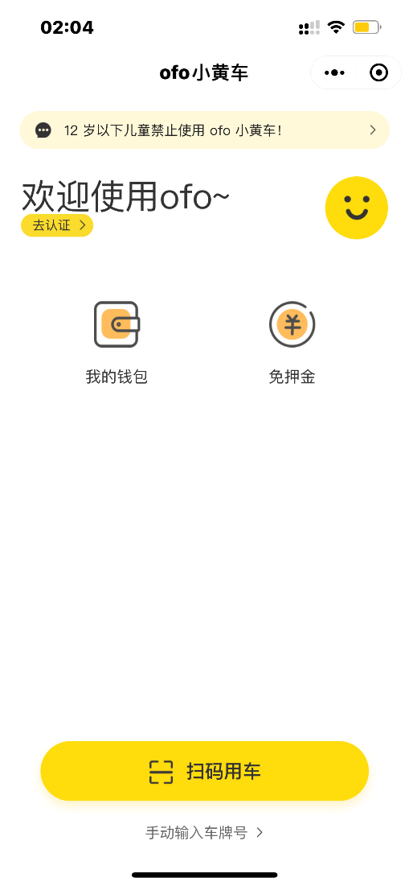 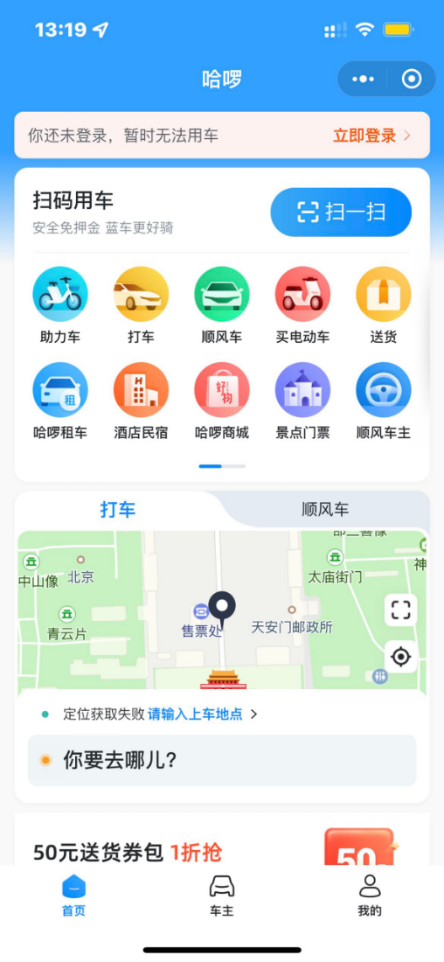

***Figure Appendix A.1.1 Yellow car rental interface***

***&***

***Figure Appendix A.1.2 Hello Bike Rental Interface***

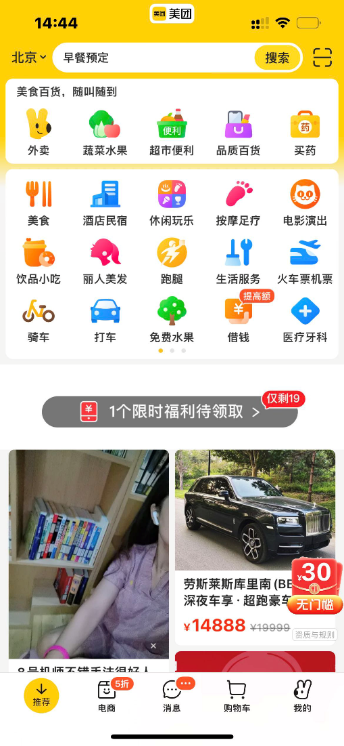

***Figure Appendix A.1.3 The interface of Meituan Bike Rental***

2. Design

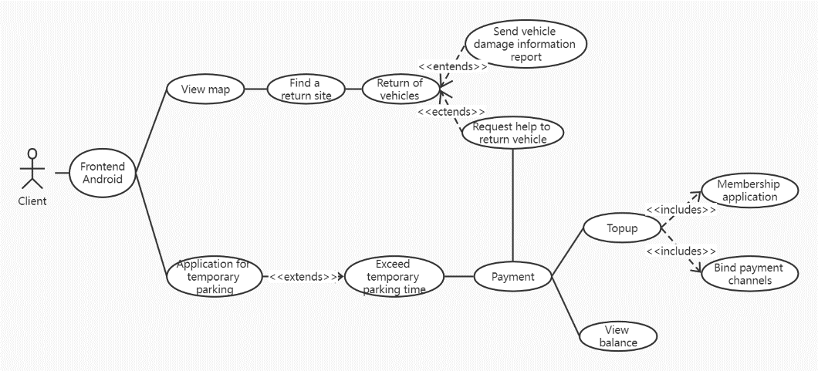

***Figure Appendix A.2.1 Client vehicle returning use case diagram***

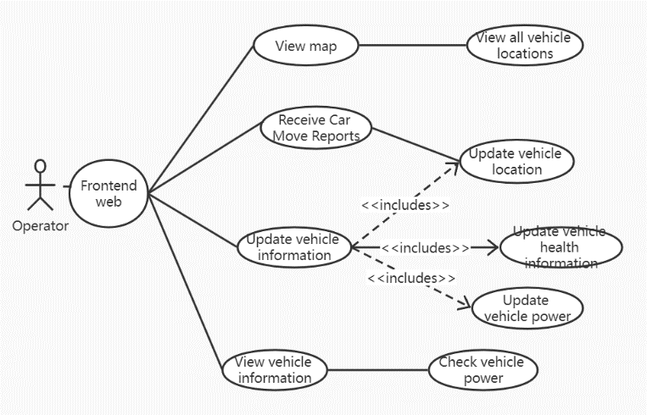

***Figure Appendix A.2.2 Operator use case diagram***

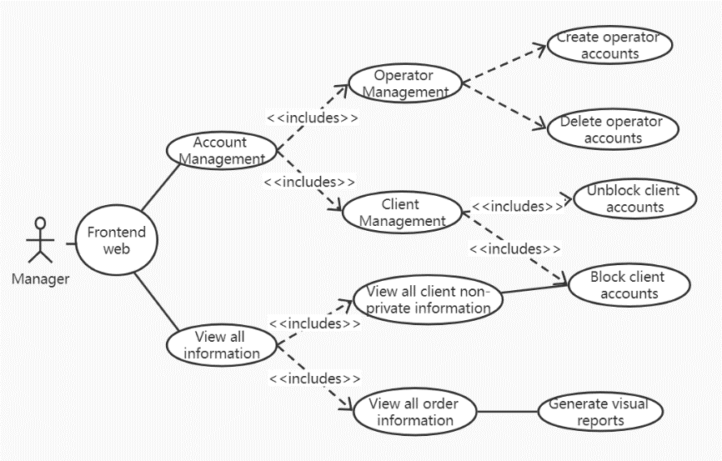

***Figure Appendix A.2.3 Manager use case diagram***

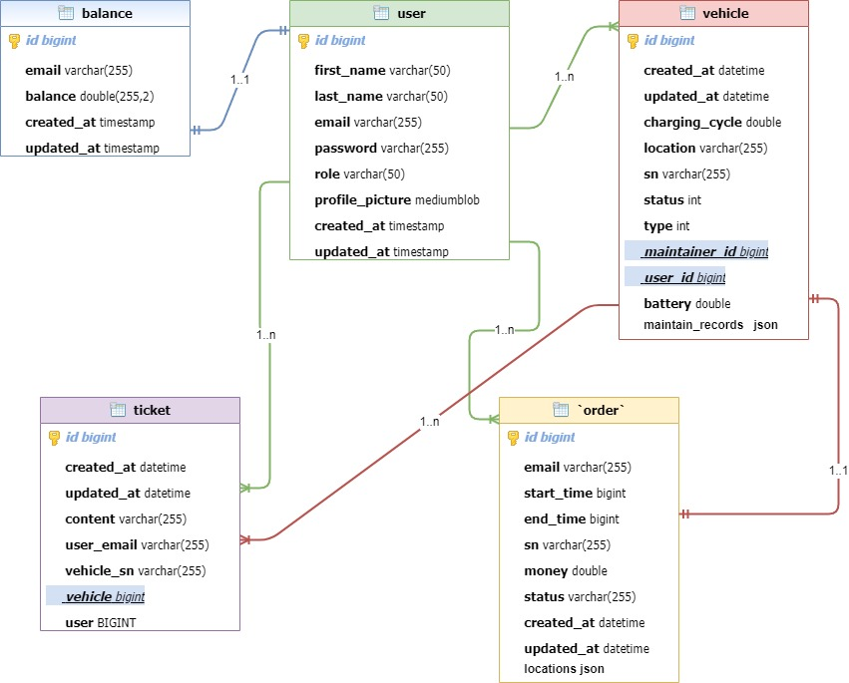

***Figure Appendix A.2.4 ER diagram***

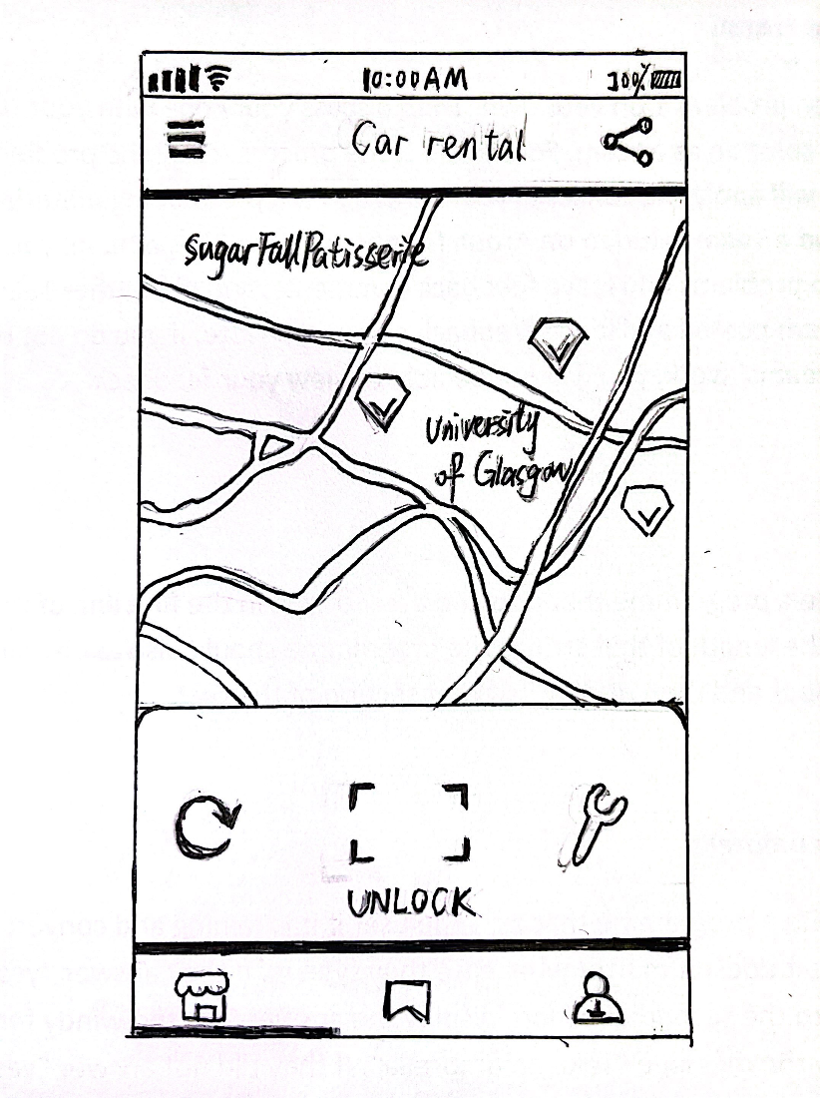

***Figure Appendix A.2.5 Prototypes***

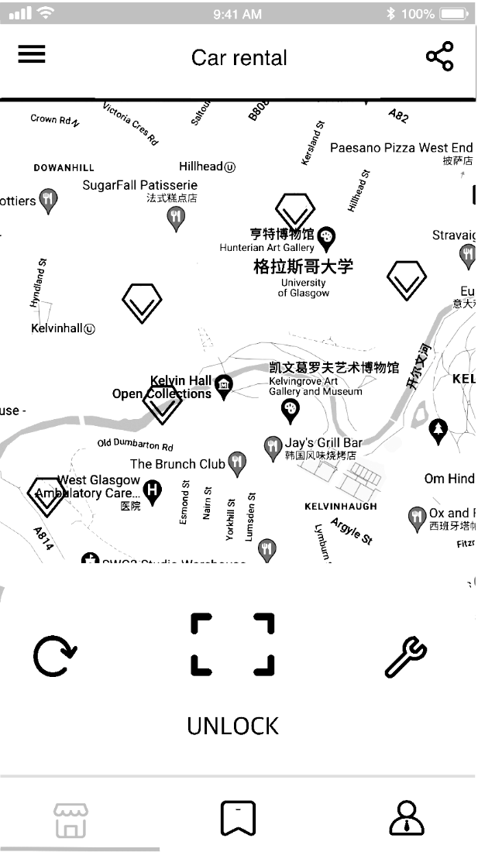

***Figure Appendix A.2.6 Wireframe Diagram***

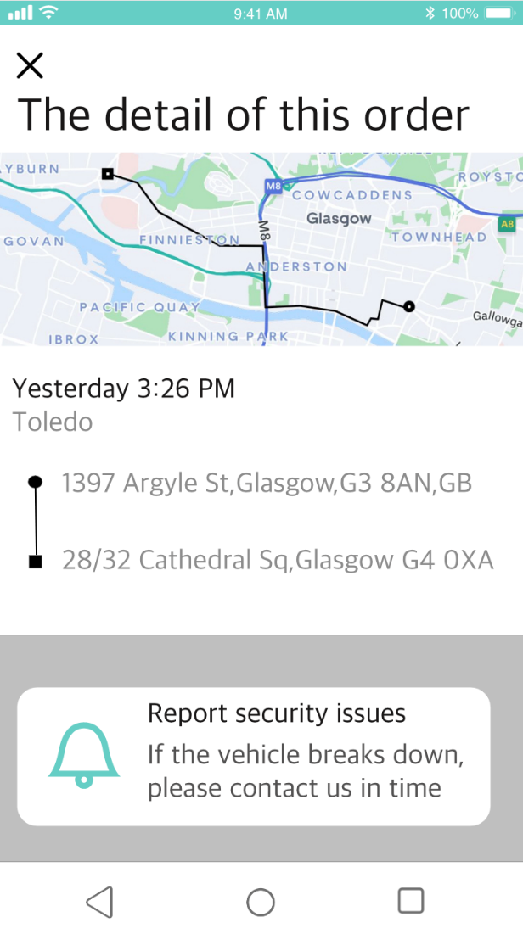

***Figure Appendix A.2.7 UI diagram***

###### <UI Design>

Registration and Login Module

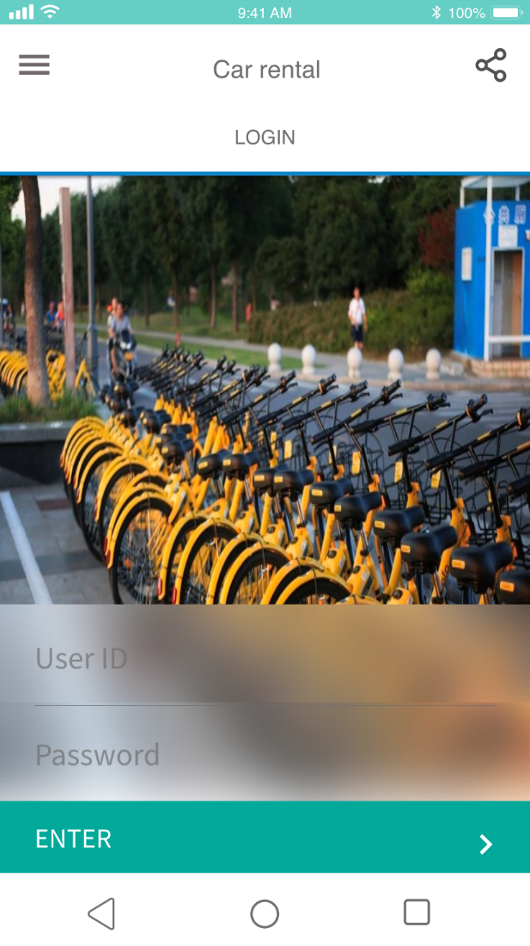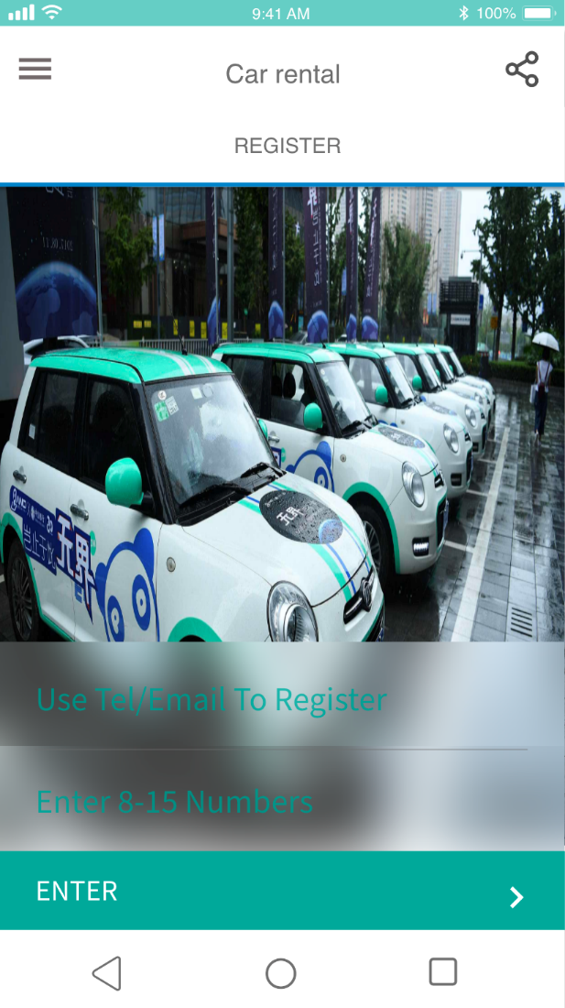Vehicle selection module

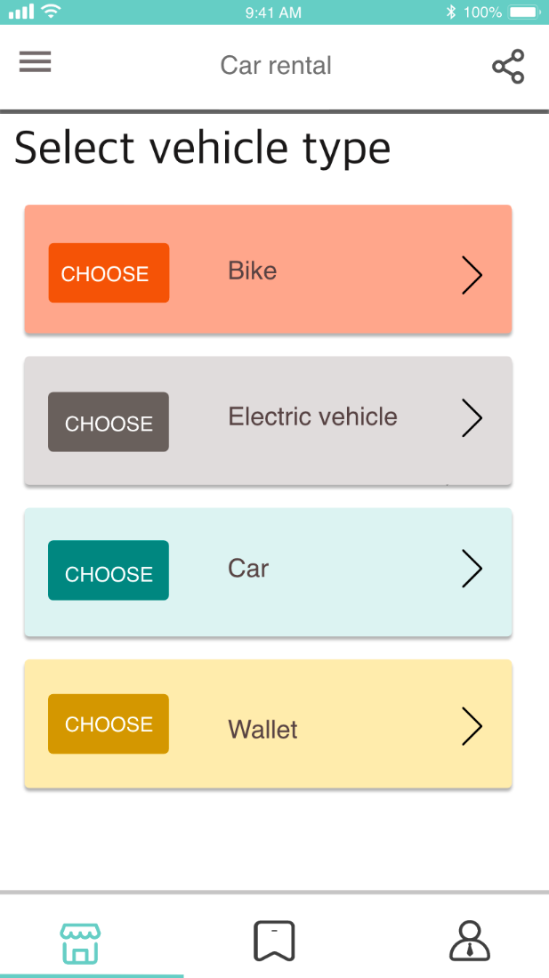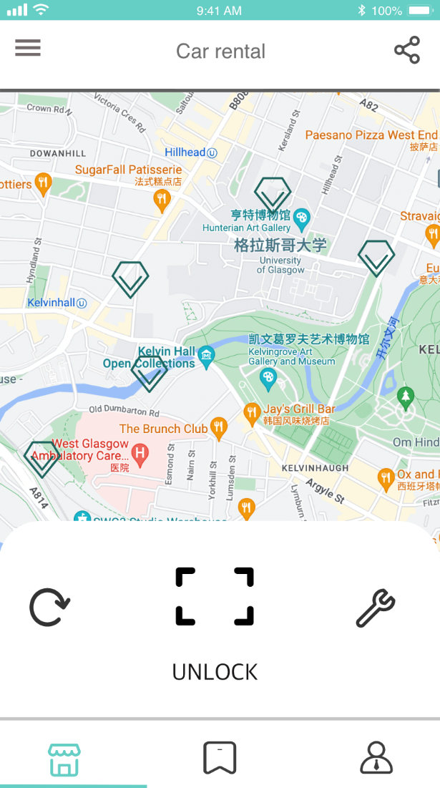

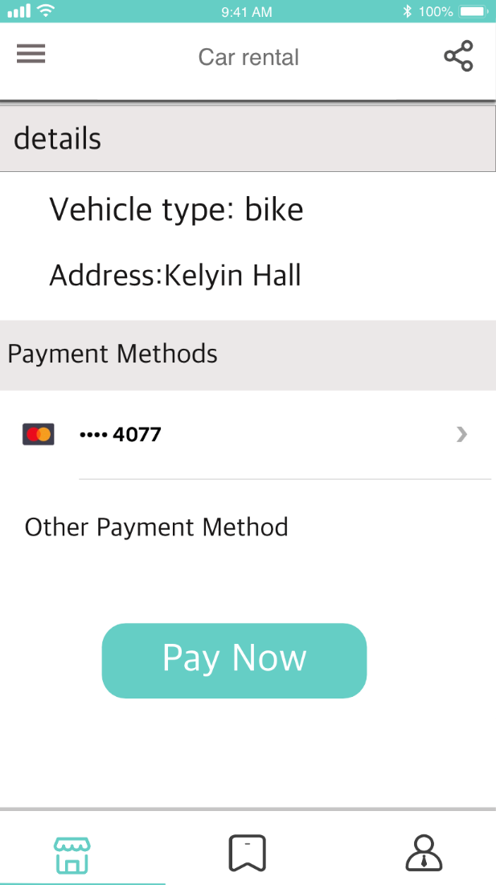

Order Module

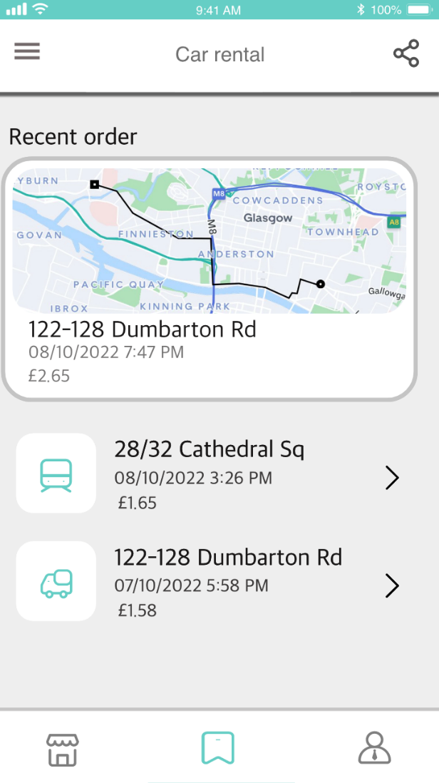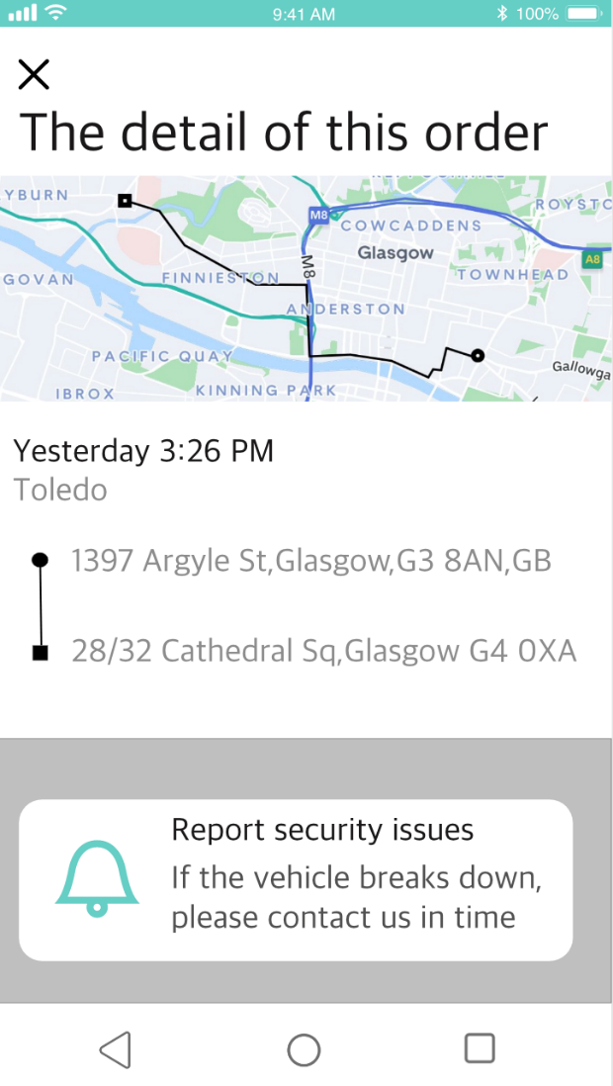Personal Module

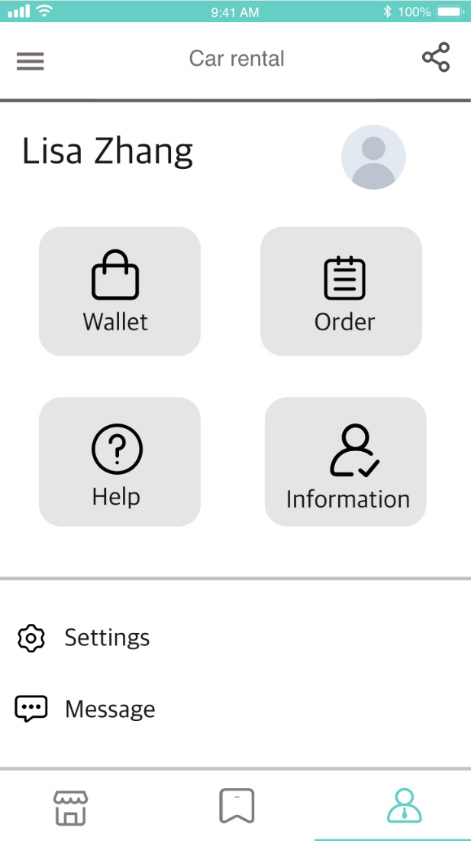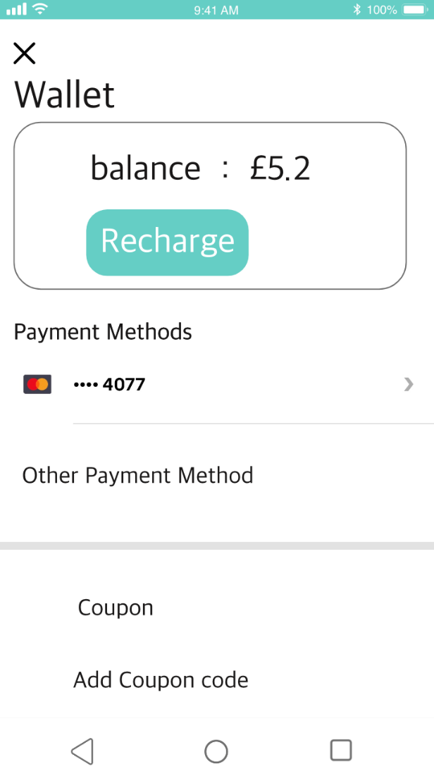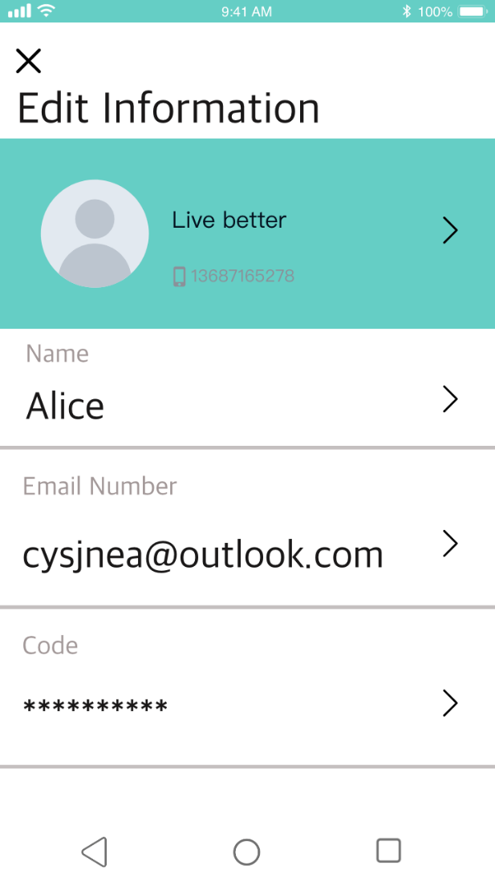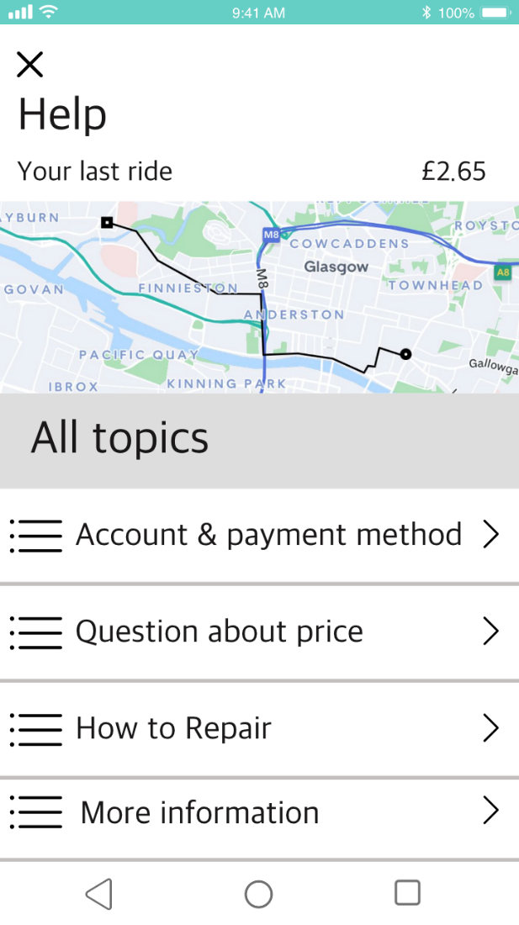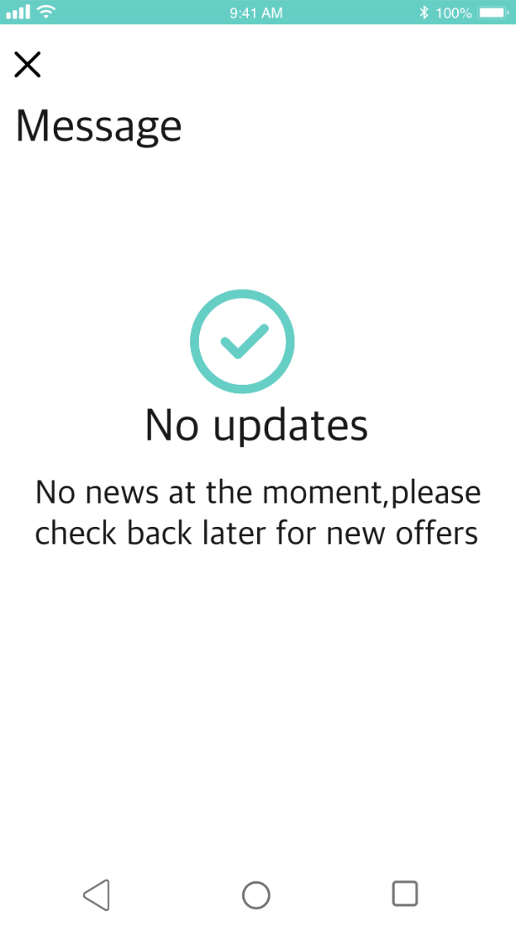

Operator module

View all vehicles

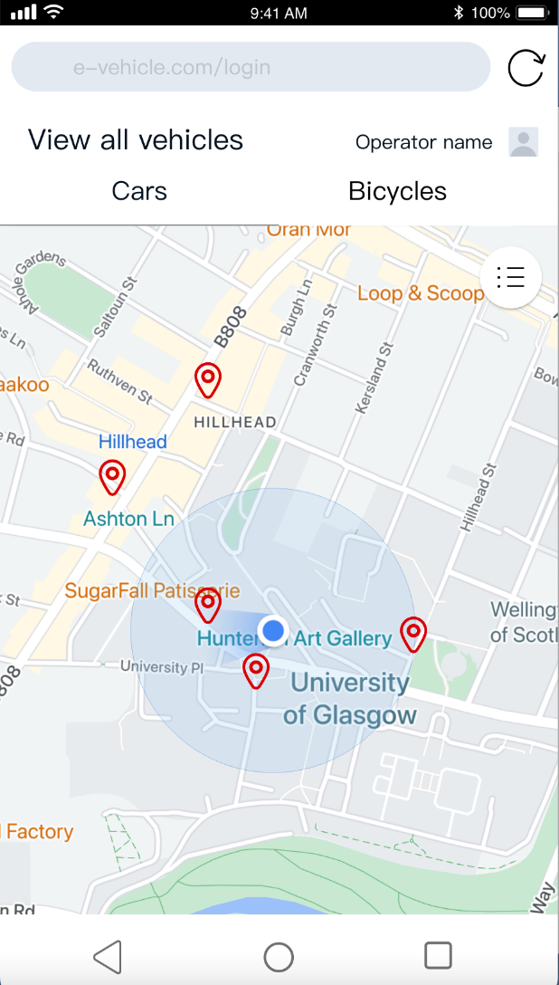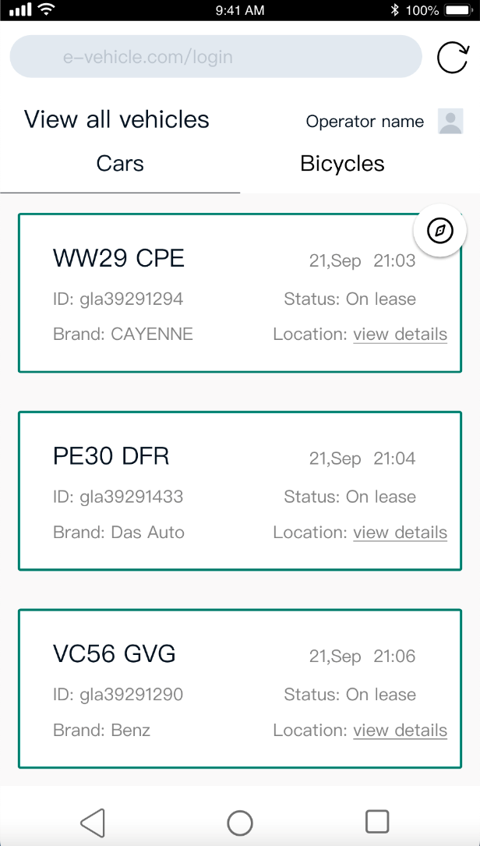Update vehicle information

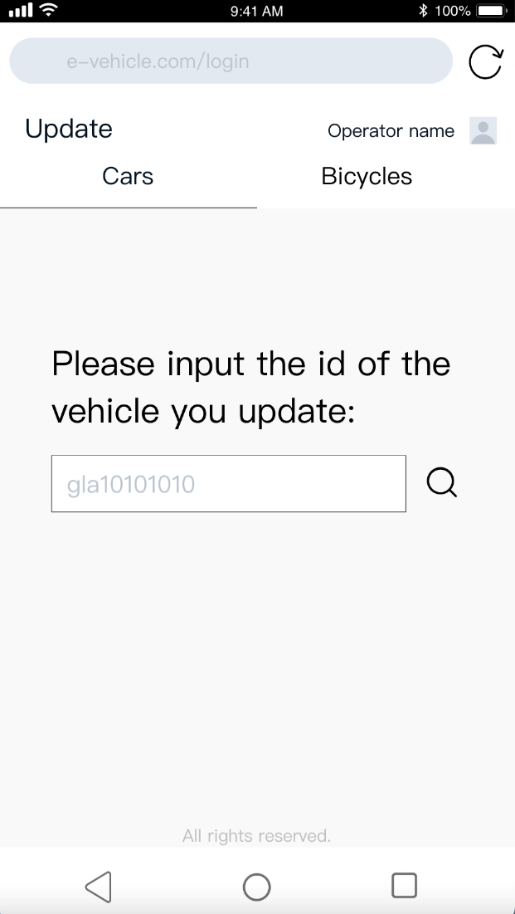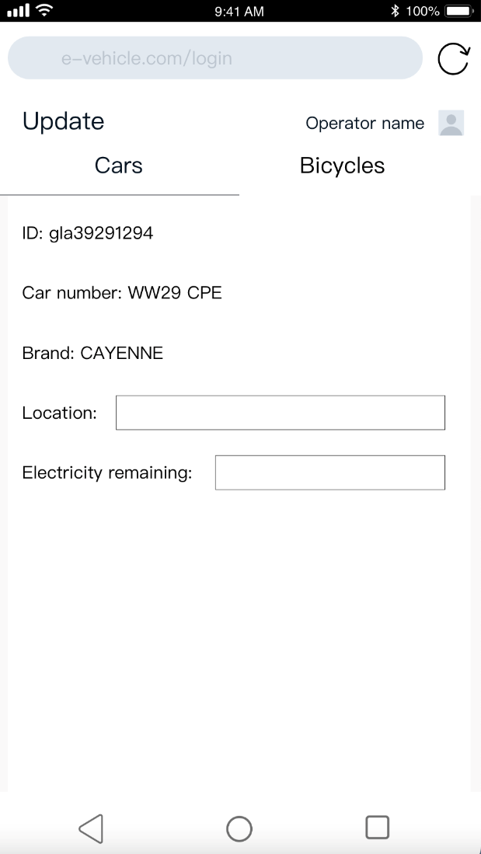

###### < Mobile-end code showcase >

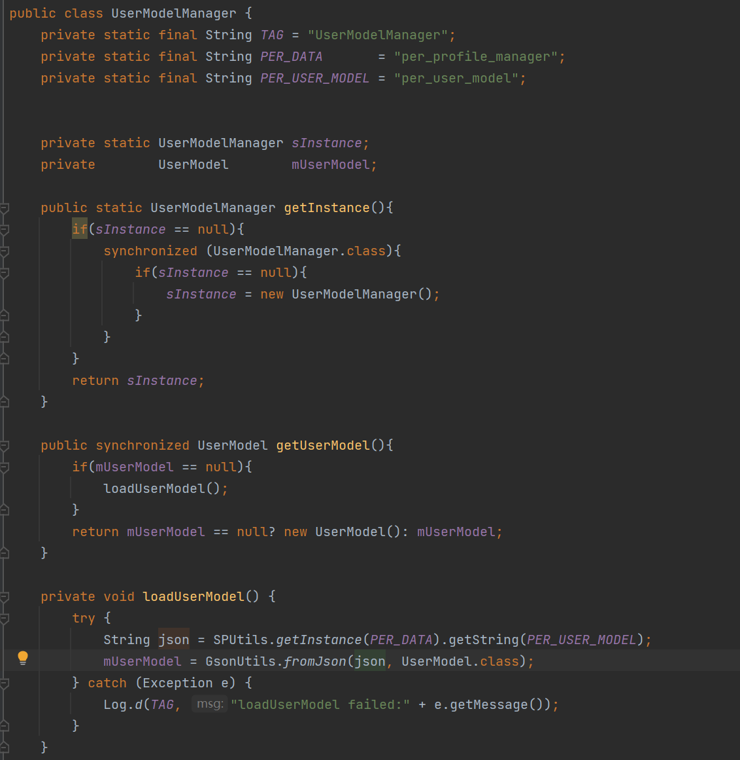

***Figure Appendix C.1.1 UserModeManager***

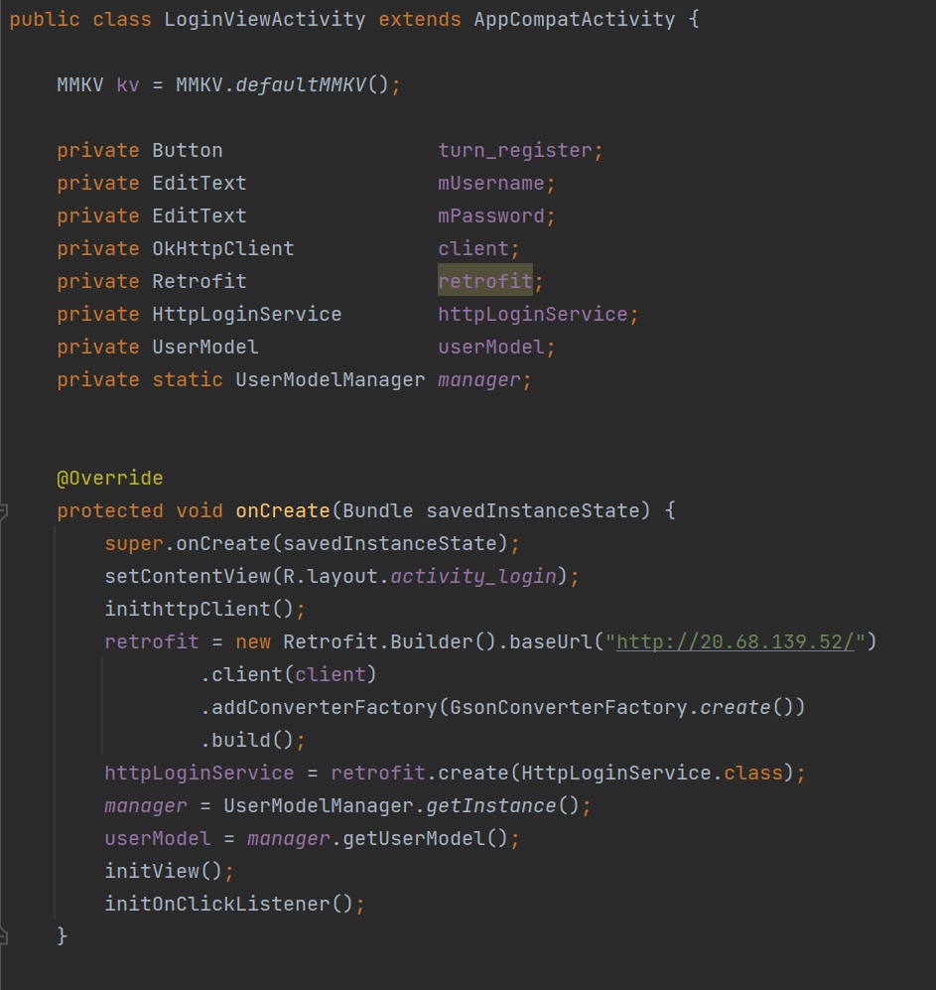

***Figure Appendix C.1.2 LoginViewOncreate***

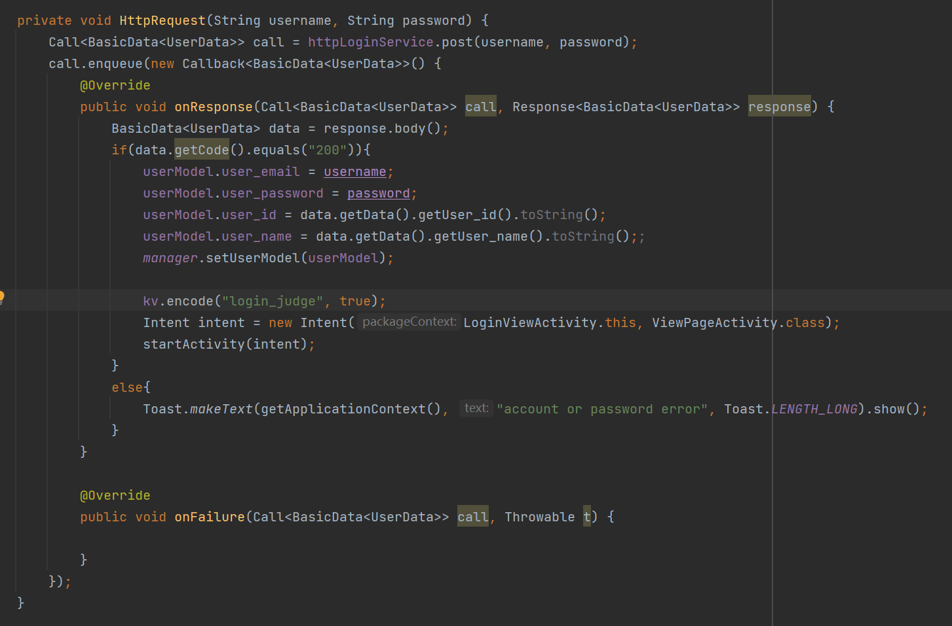

***Figure Appendix C.1.3 LoginRequest***

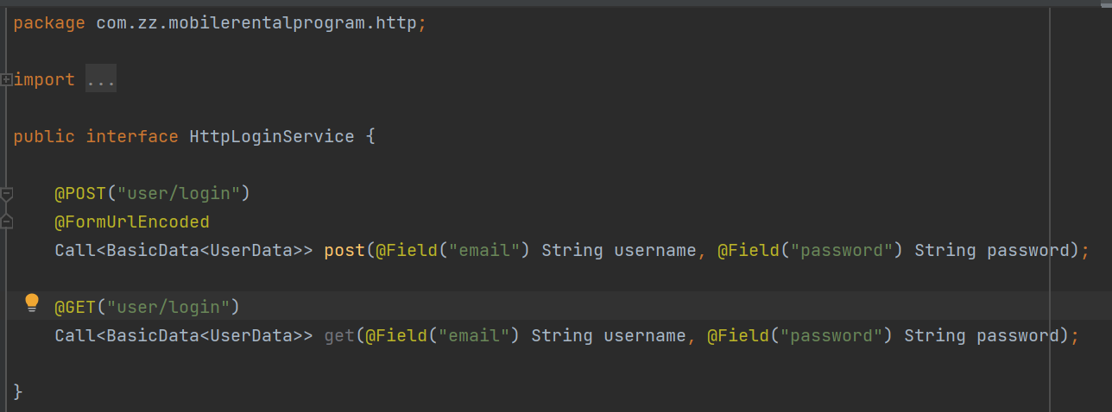

***Figure Appendix C.1.4 LoginHttpInterface***

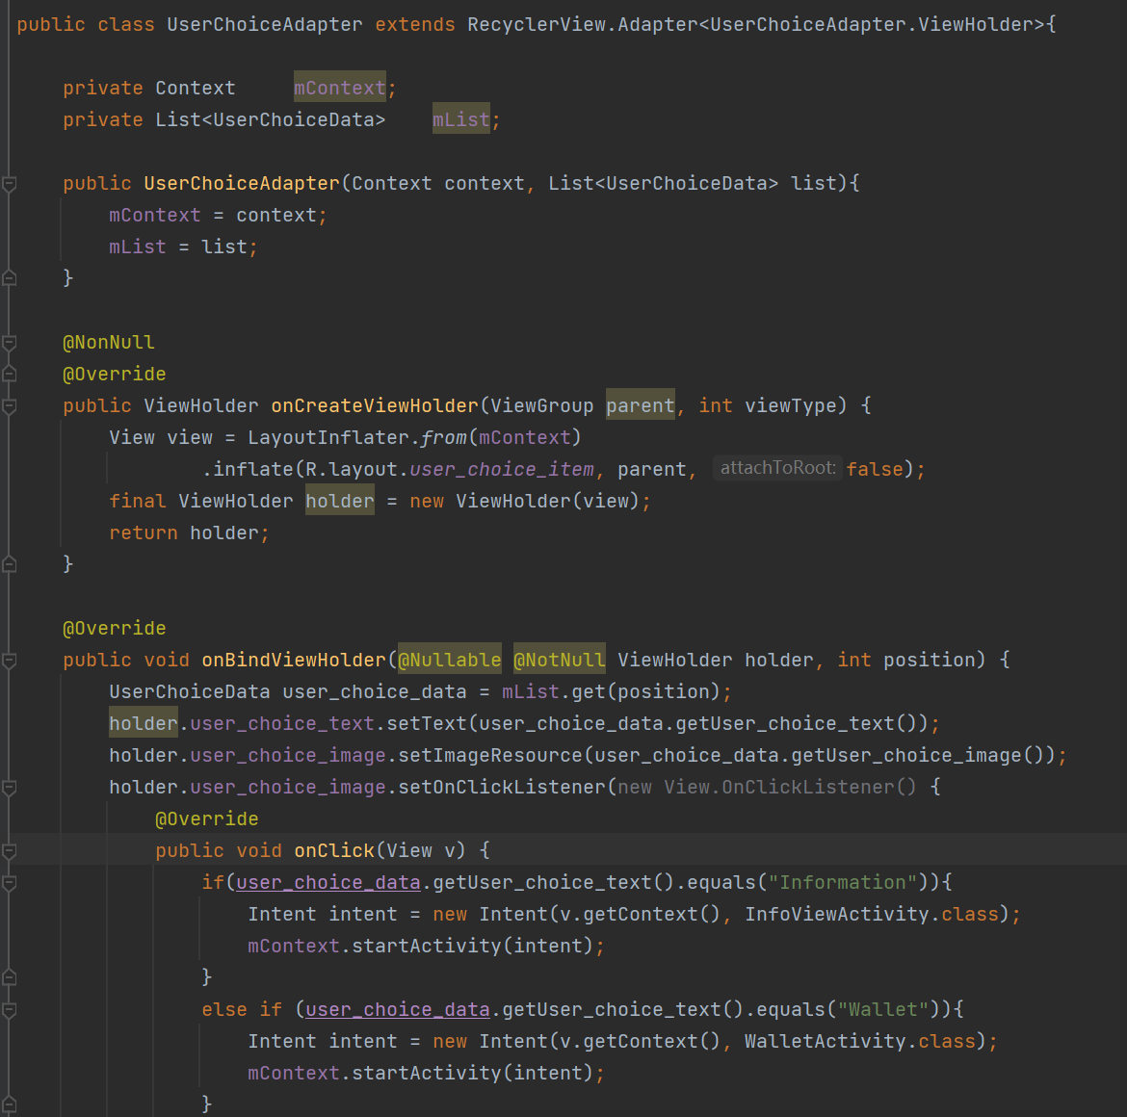

***Figure Appendix C.1.5 RecyclerViewAdapter***

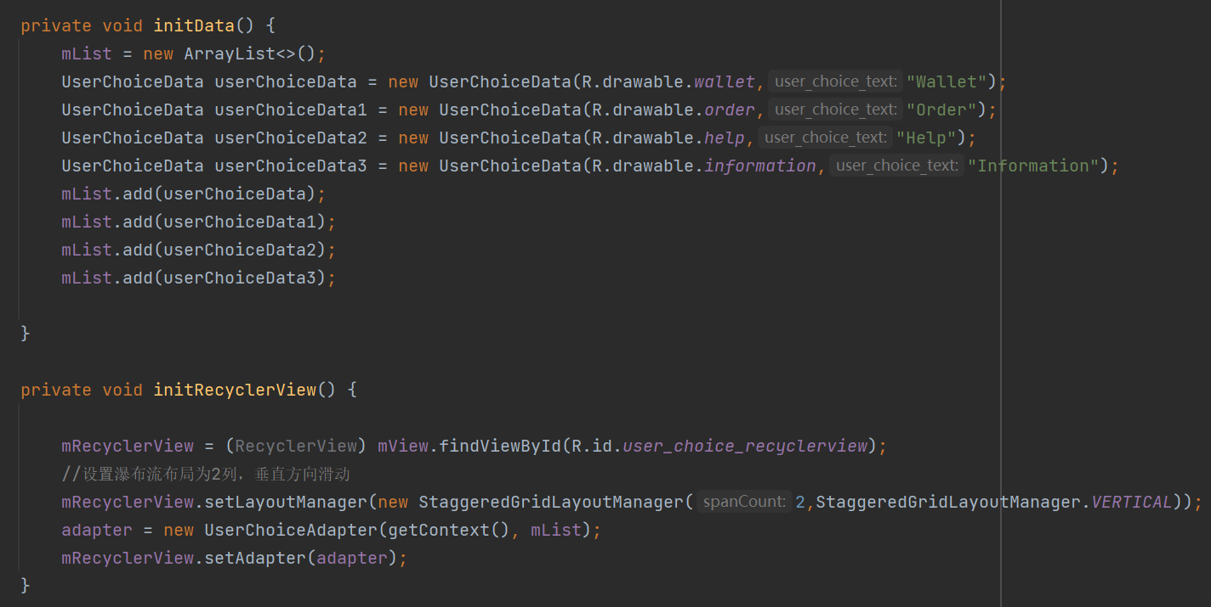

***Figure Appendix C.1.6 RecyclerViewInit***

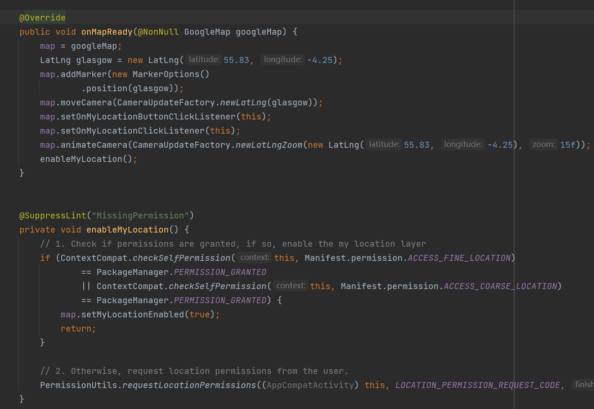

***Figure Appendix C.1.7 GoogleMapPrepare***

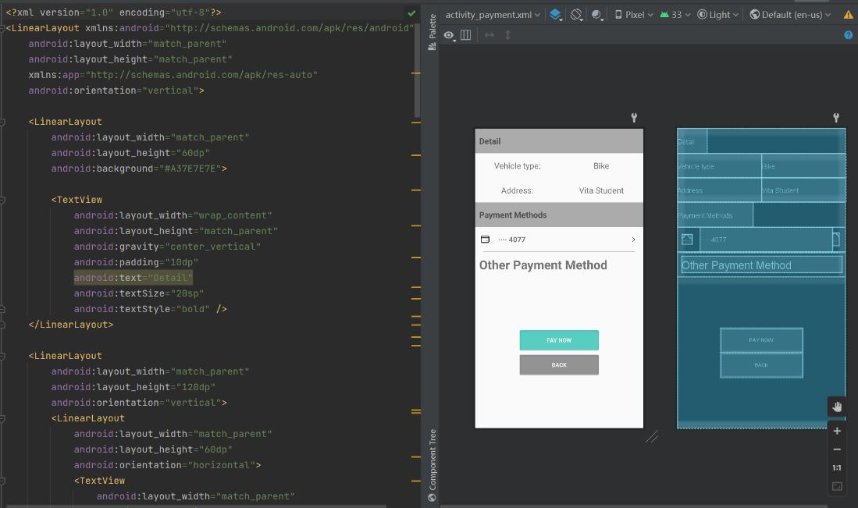

***Figure Appendix C.1.8 ViewXMLSample1***

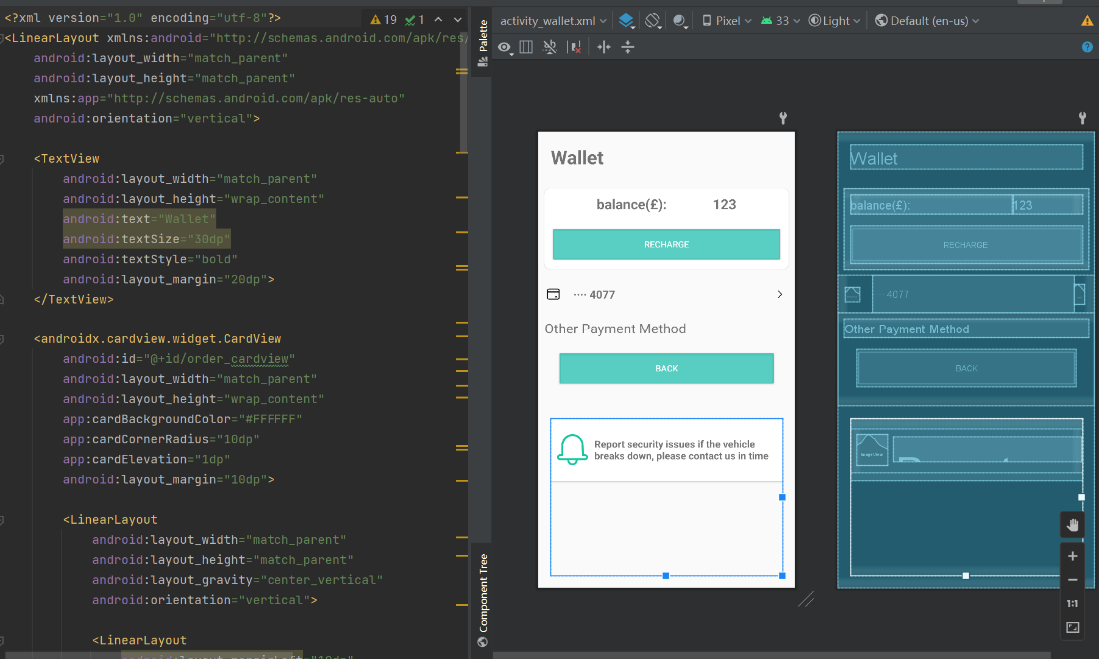

***Figure Appendix C.1.9 ViewXMLSample2***

###### < Back-end code showcase >

1. User
   1. Controller

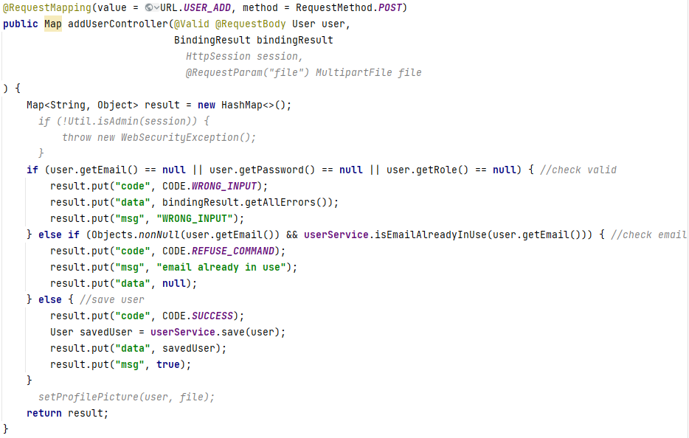

***Figure Appendix D.1.1.1: addUserController***

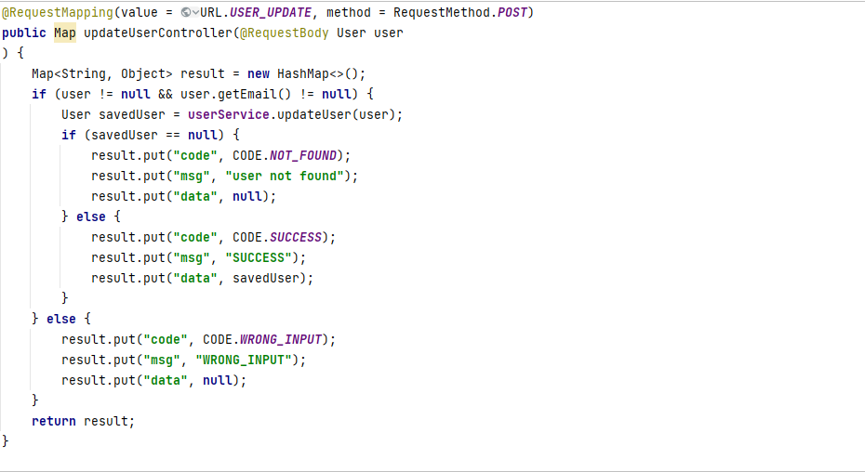

***Figure Appendix D.1.1.2: updateUserController***

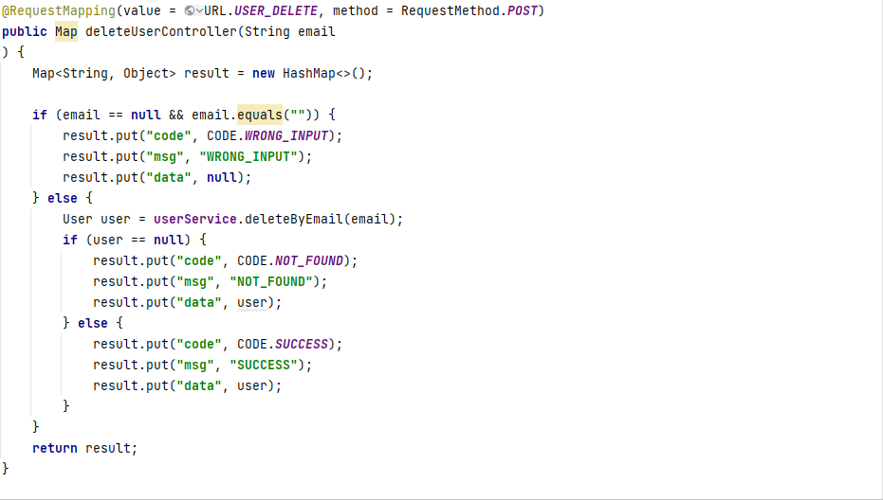

***Figure Appendix D.1.1.3: deleteUserController***

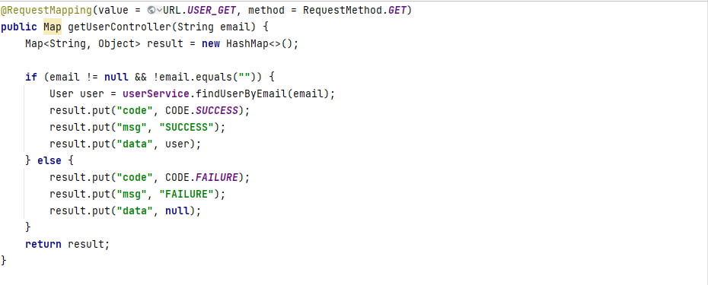

***Figure Appendix D.1.1.4: getUserController***

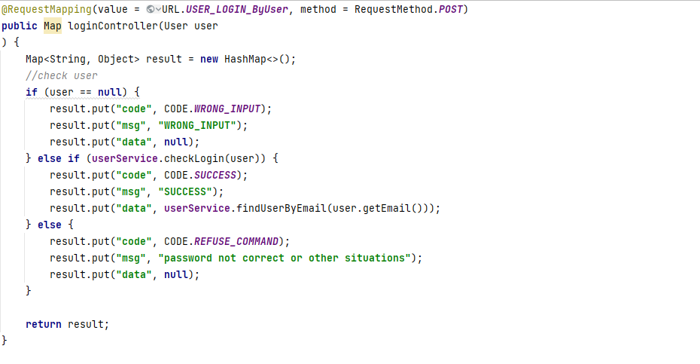

***Figure Appendix D.1.1.5: loginUserControllerByUser***

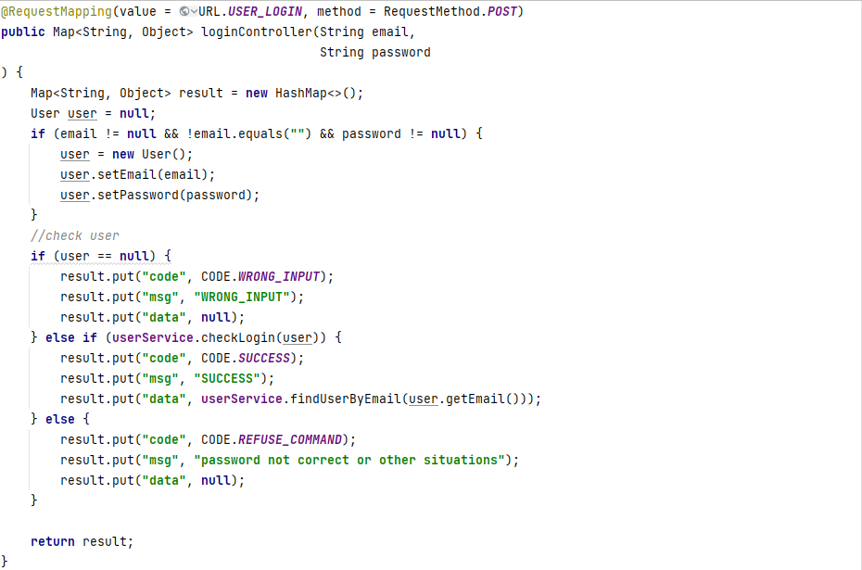

***Figure Appendix D.1.1.6: loginUserControllerByEmail&Password***

* 1. Service

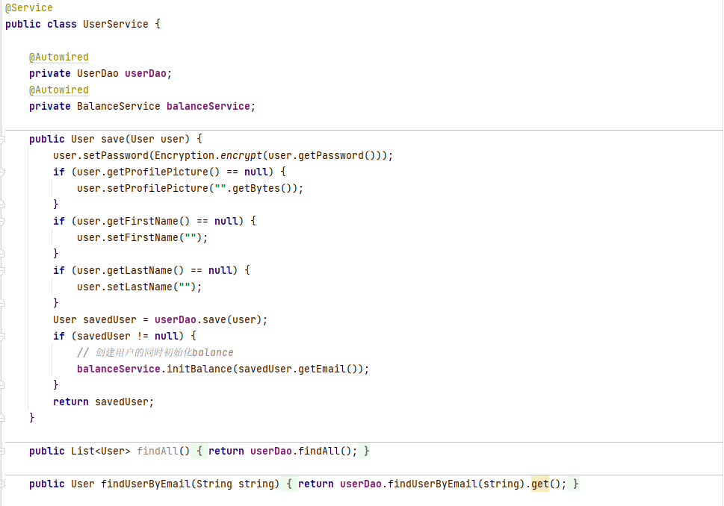

***Figure Appendix D.1.2.1: userService(1)***

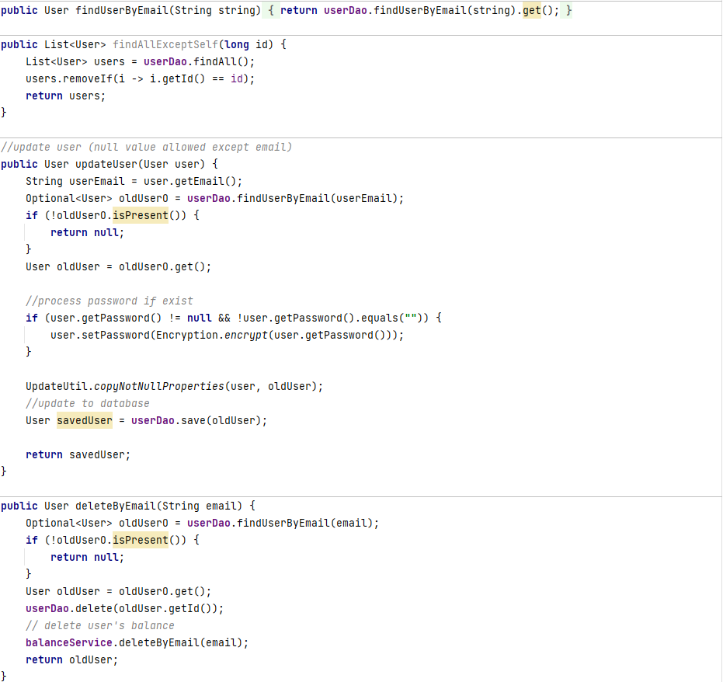

***Figure Appendix D.1.2.2: userService(2)***

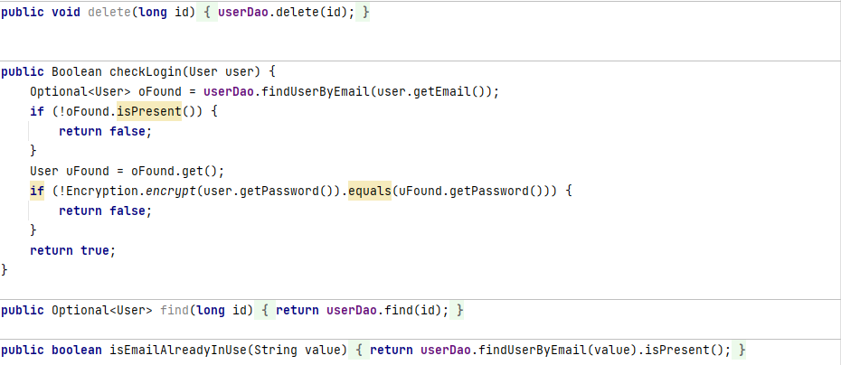

***Figure Appendix D.1.2.3: userService(3)***

* 1. Dao

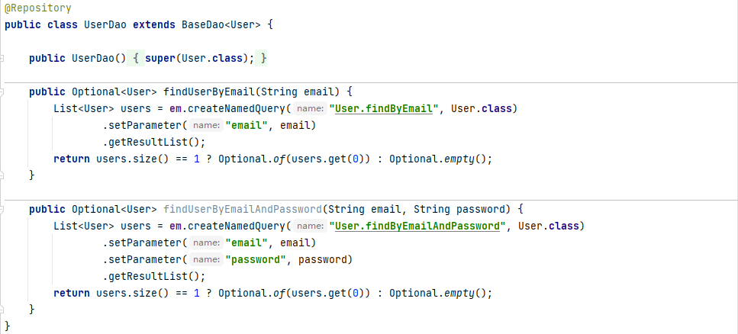

***Figure Appendix D.1.3.1: userDao***

1. Vehicle
   1. Controller

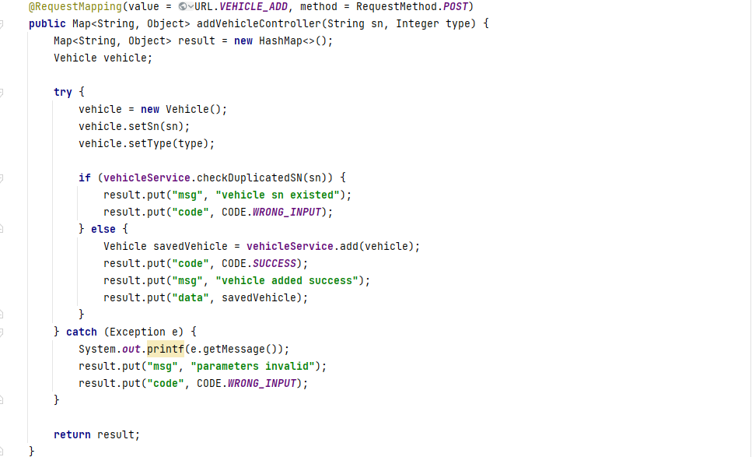

***Figure Appendix D.2.1.1: addVehicleController***

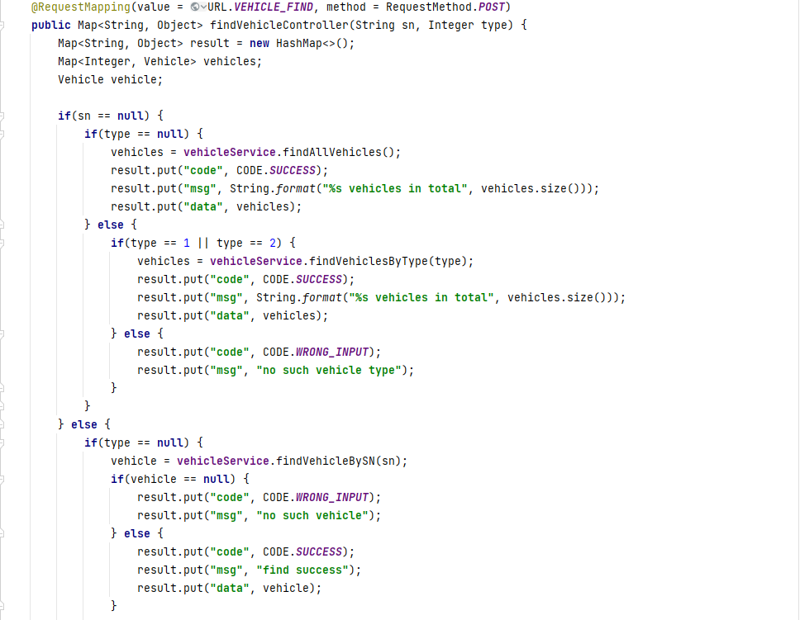 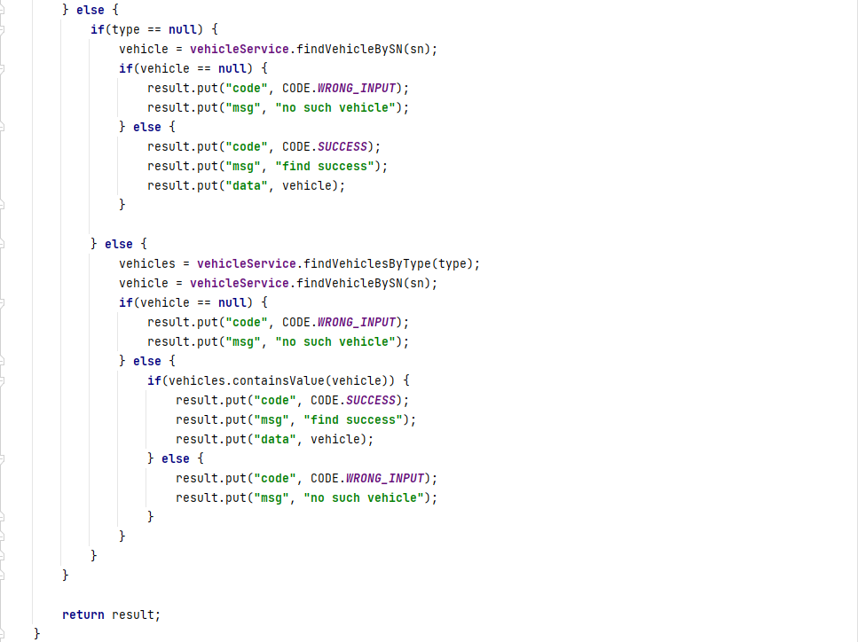

***Figure Appendix D.2.1.2: findVehicleController***

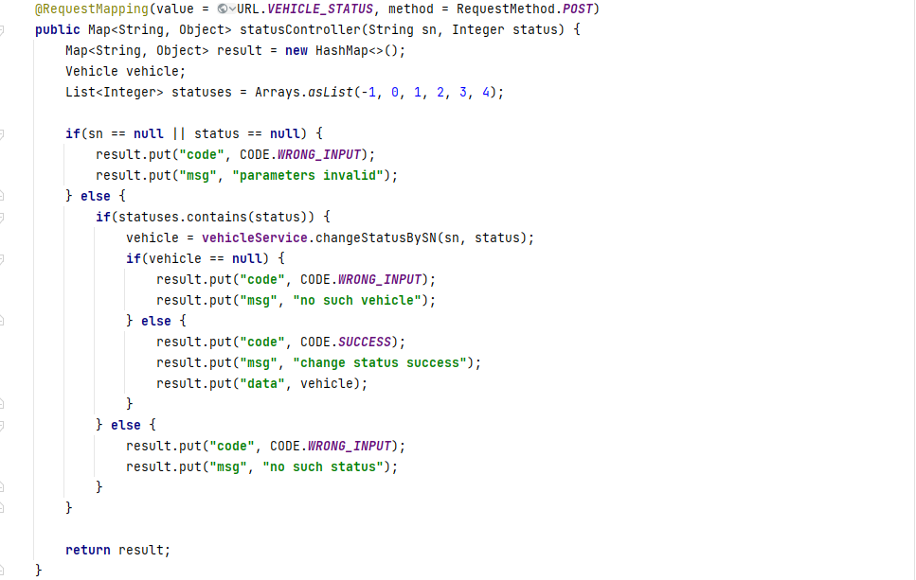

***Figure Appendix D.2.1.3: statusController***

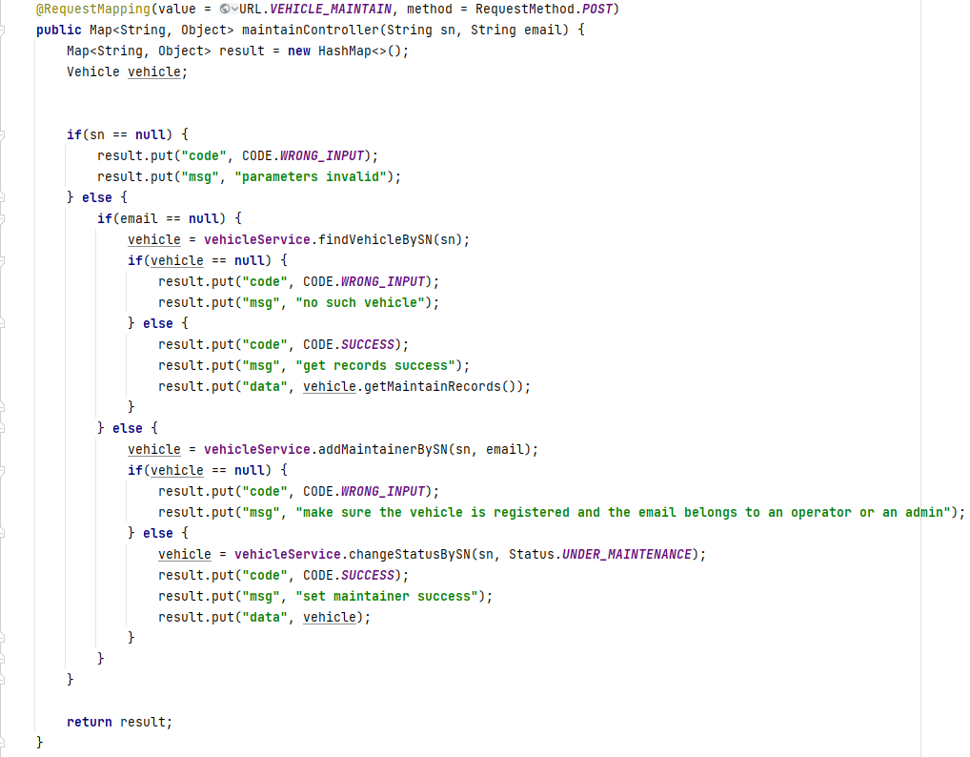

***Figure Appendix D.2.1.4: maintainController***

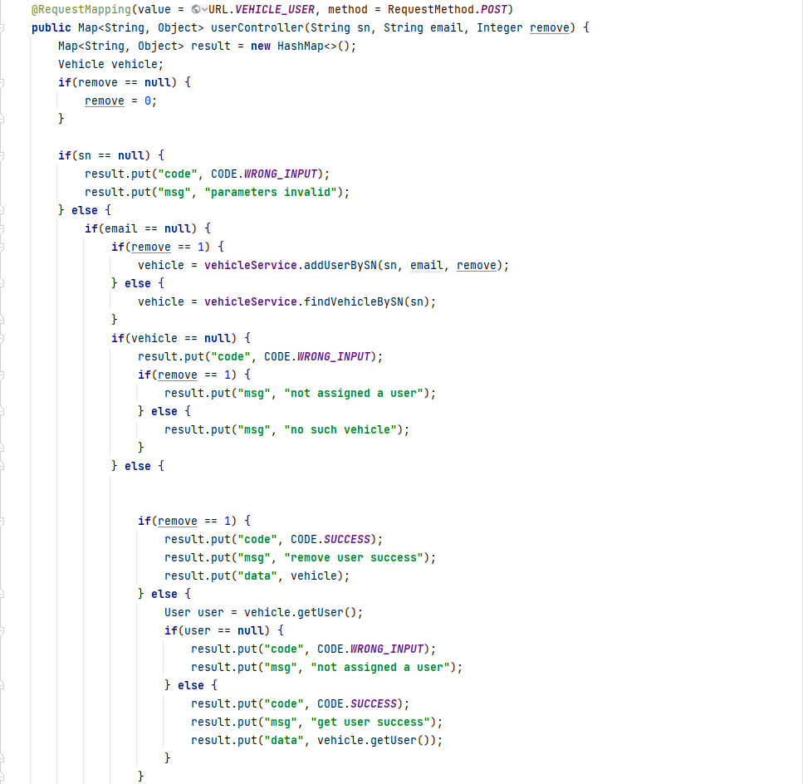 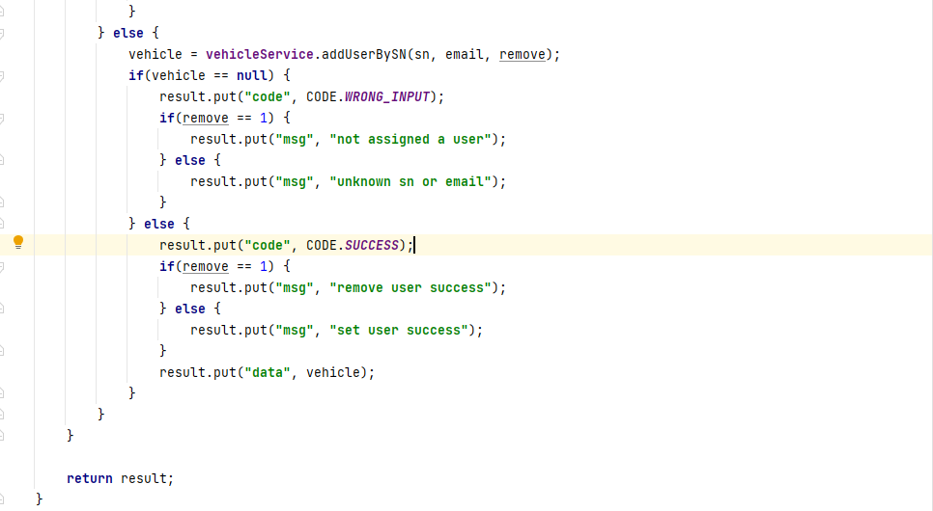

***Figure Appendix D.2.1.5: useController***

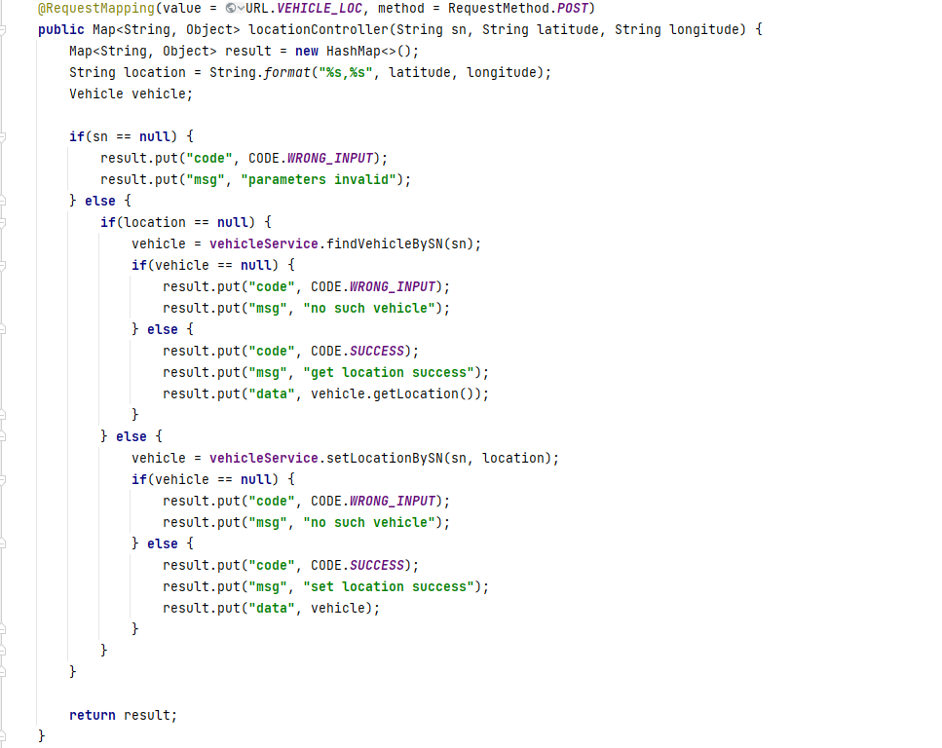

***Figure Appendix D.2.1.6: locationController***

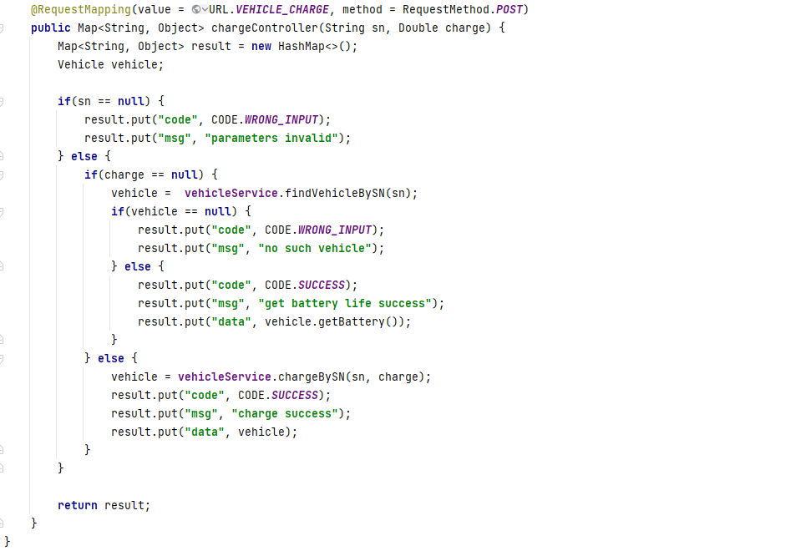

***Figure Appendix D.2.1.7: chargeController***

* 1. Service

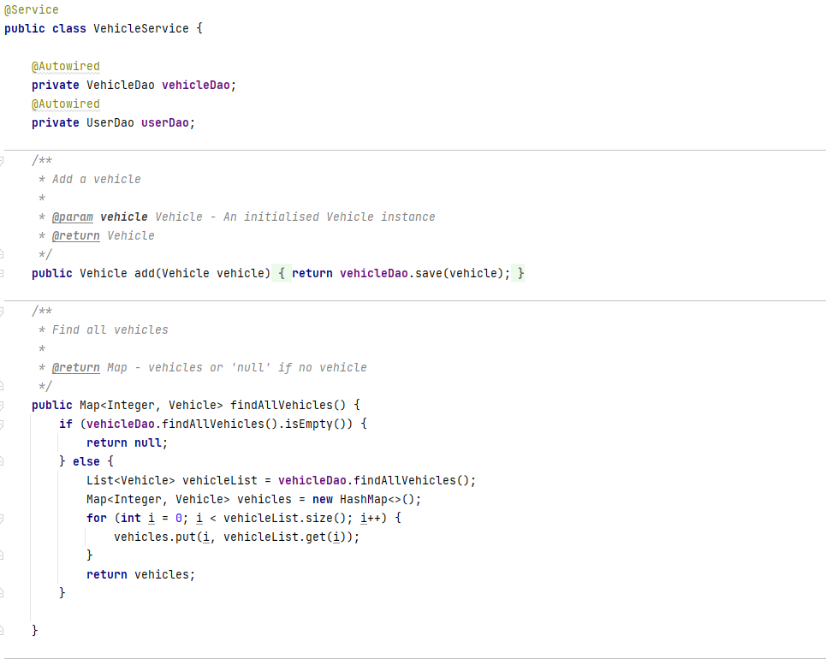

***Figure Appendix D.2.2.1: vehicleService(1)***

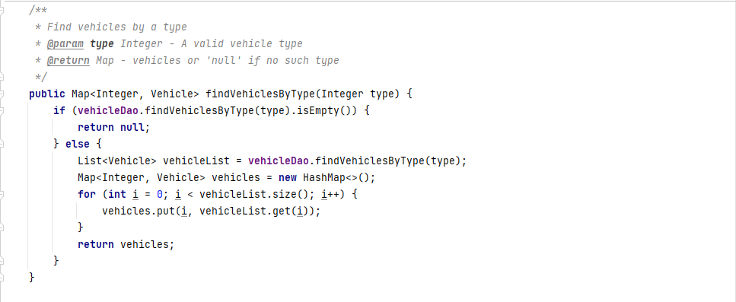

***Figure Appendix D.2.2.2: vehicleService(2)***

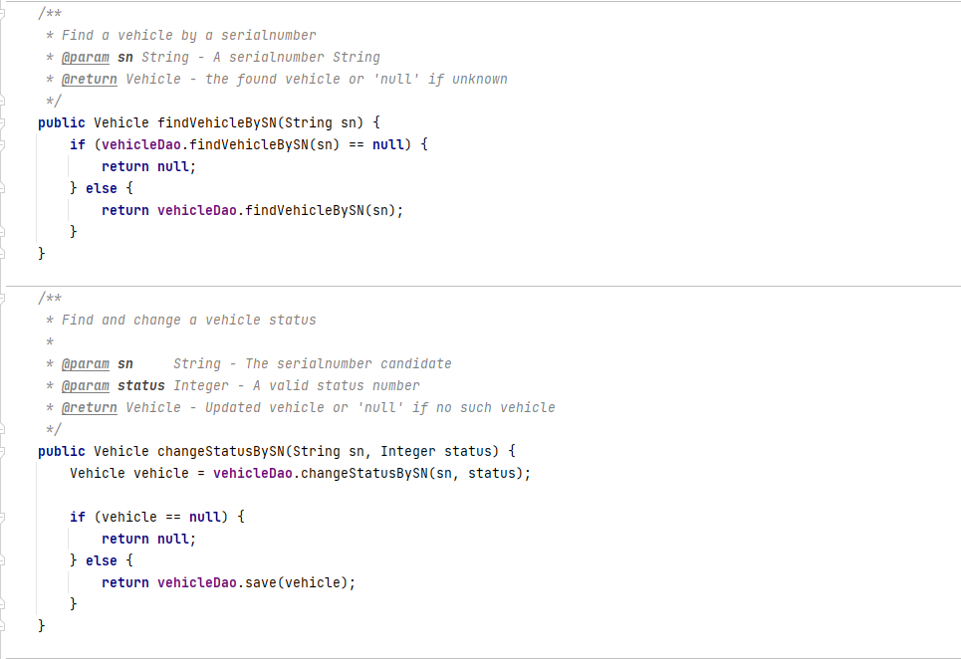

***Figure Appendix D.2.2.3: vehicleService(3)***

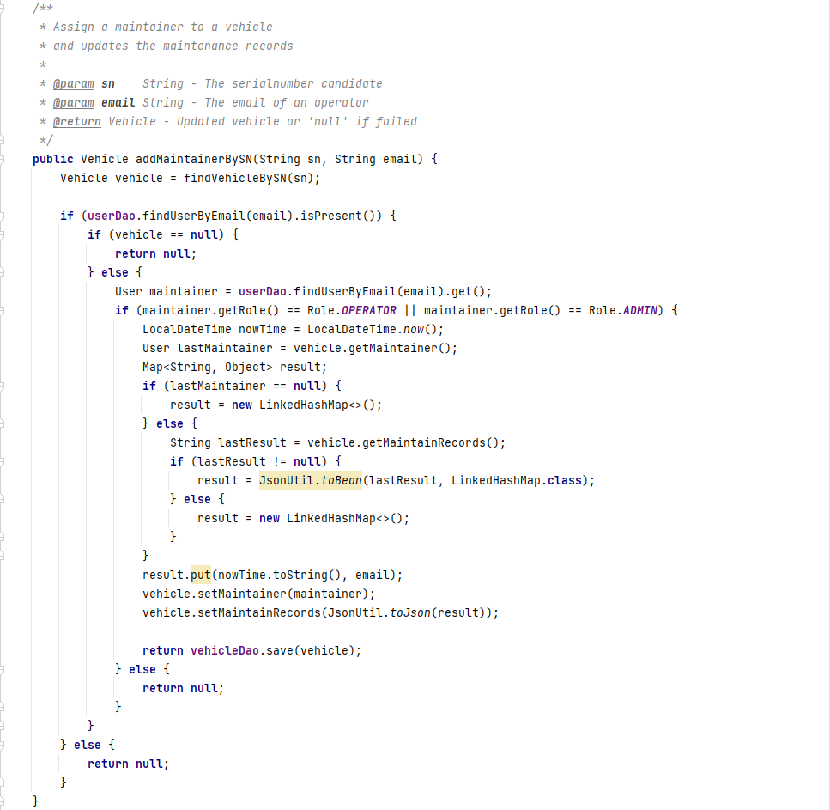

***Figure Appendix D.2.2.4: vehicleService(4)***

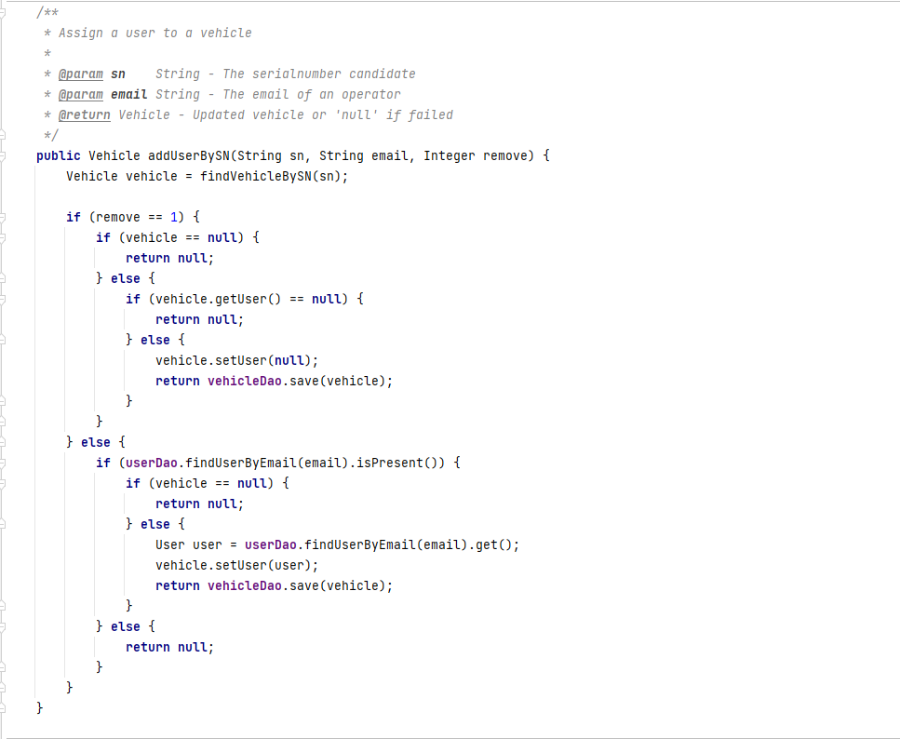

***Figure Appendix D.2.2.5: vehicleService(5)***

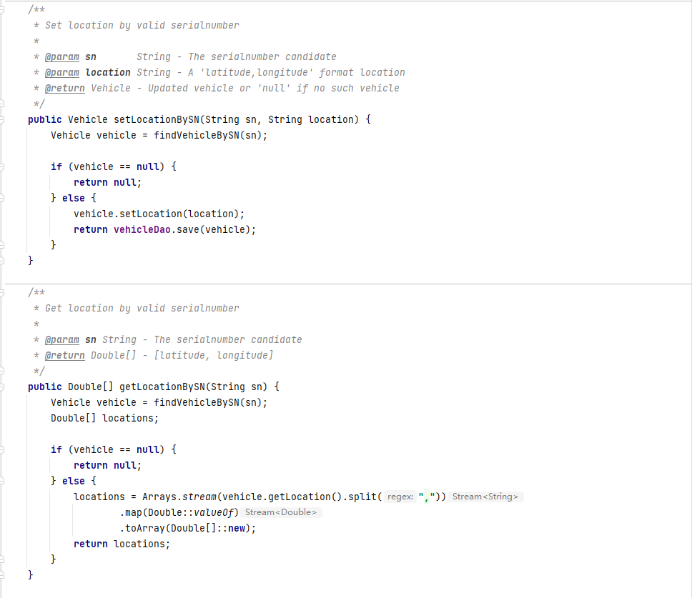

***Figure Appendix D.2.2.6: vehicleService(6)***

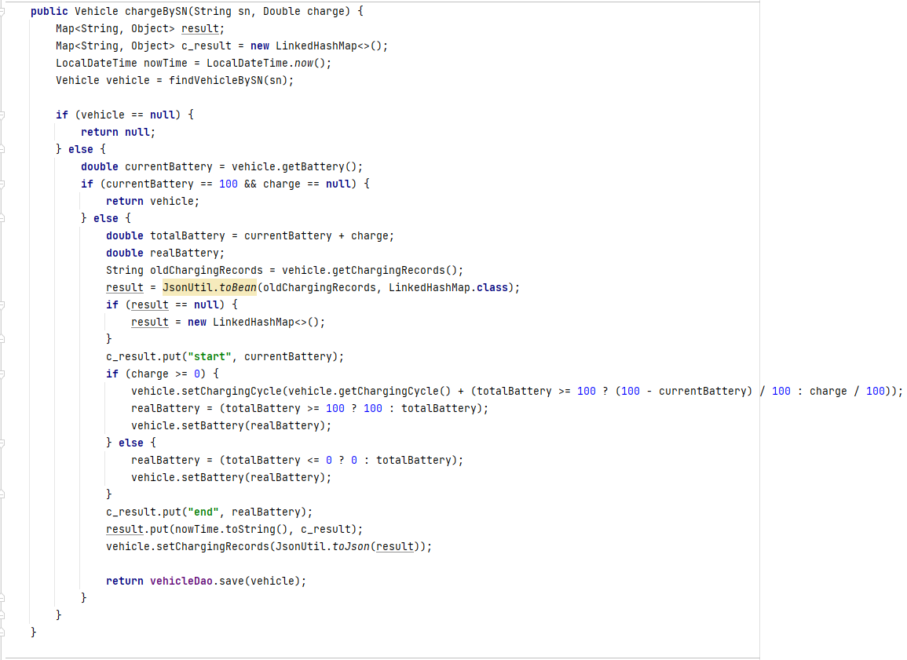

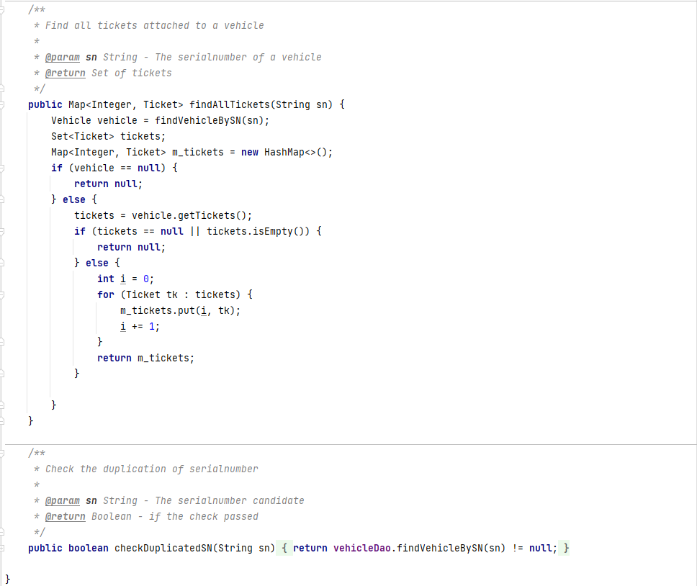

***Figure Appendix D.2.2.7: vehicleService(7)***

* 1. Dao

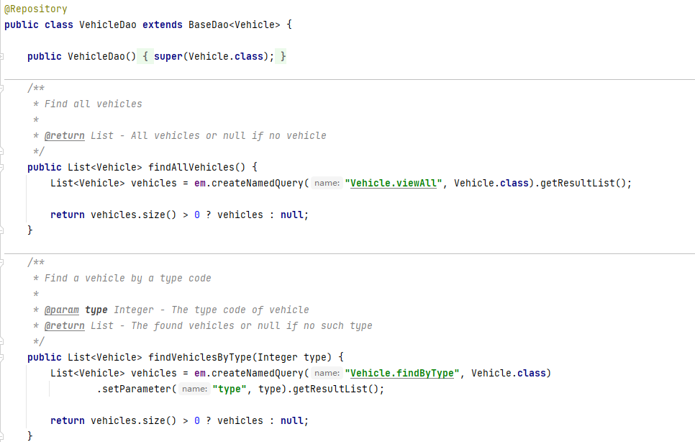

***Figure Appendix D.2.3.1: vehicleDao(1)***

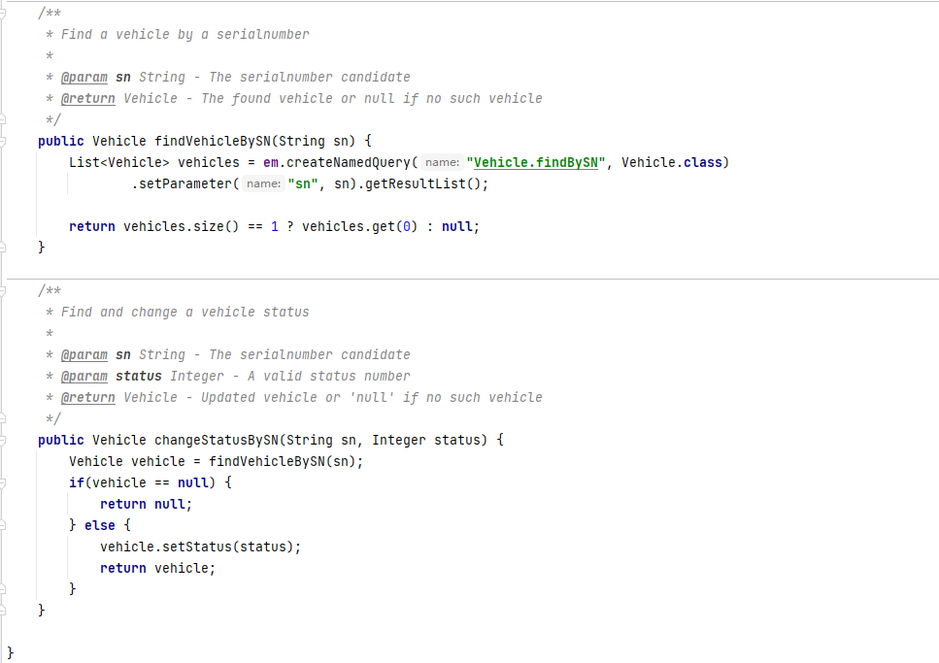

***Figure Appendix D.2.3.2: vehicleDao(2)***

1. Order
   1. Controller

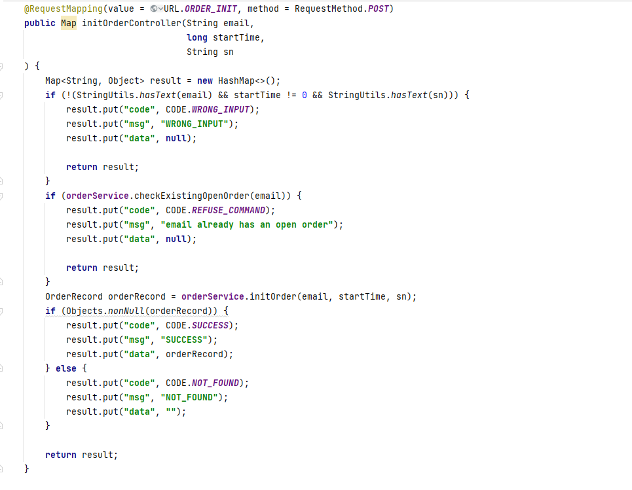

***Figure Appendix D.3.1.1:initOrderController***

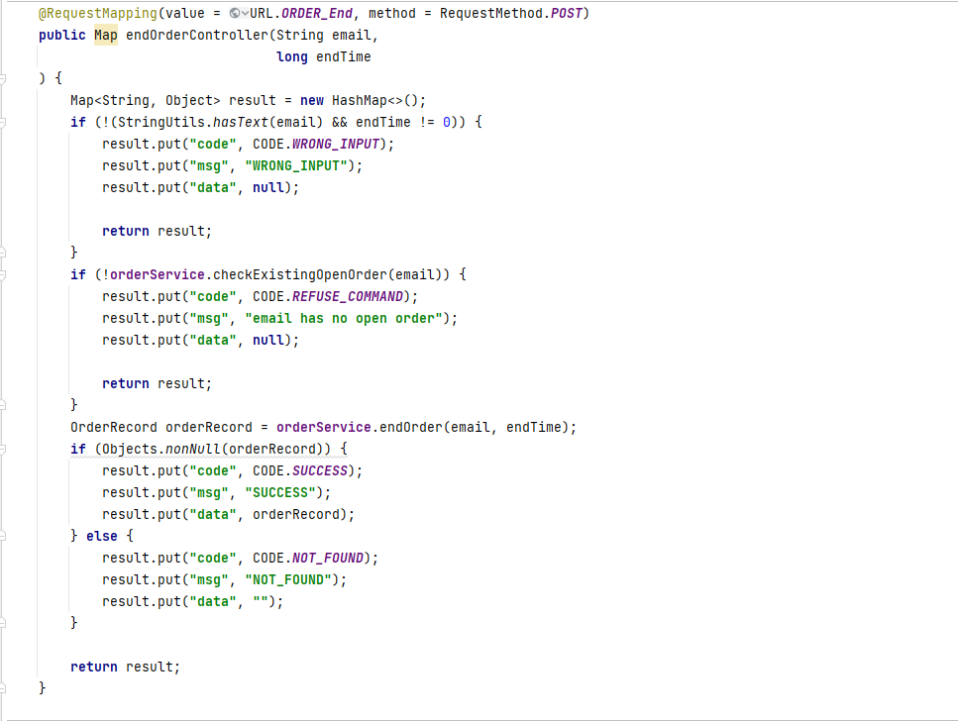

***Figure Appendix D.3.1.2: endOrderController***

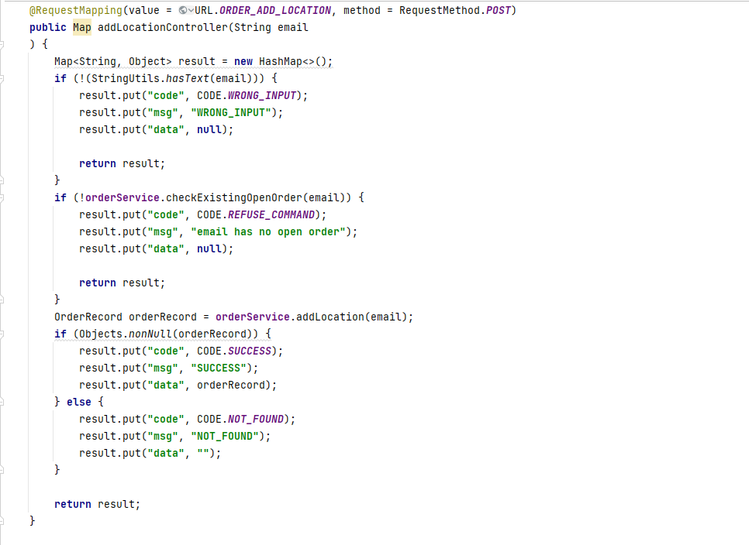

***Figure Appendix D.3.1.3: addLocationController***

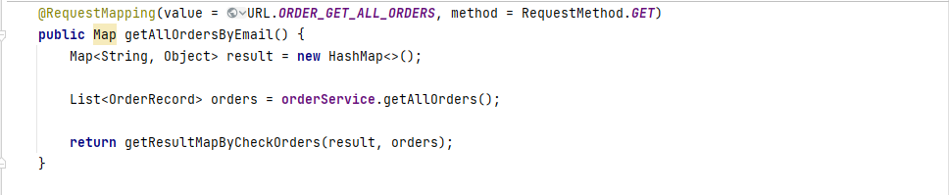

***Figure Appendix D.3.1.4: getAllOrdersByEmail***

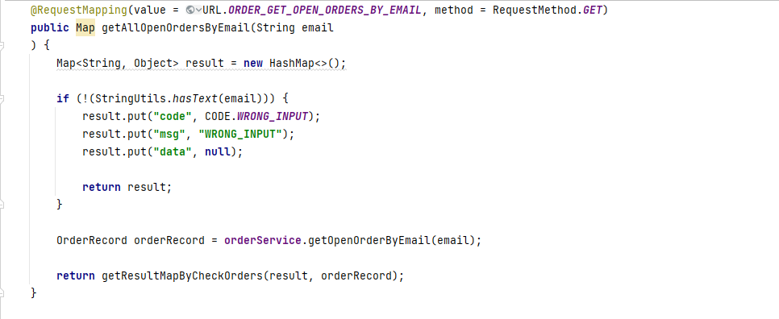

***Figure Appendix D.3.1.5: getAllOpenOrdersByEmail***

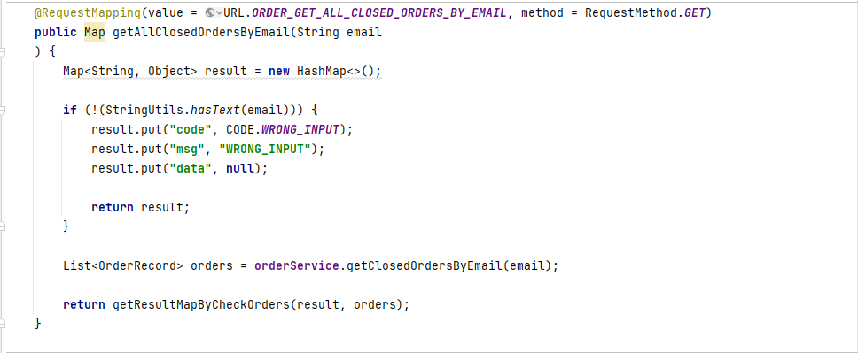

***Figure Appendix D.3.1.6: getAllClosedOrderByEmail***

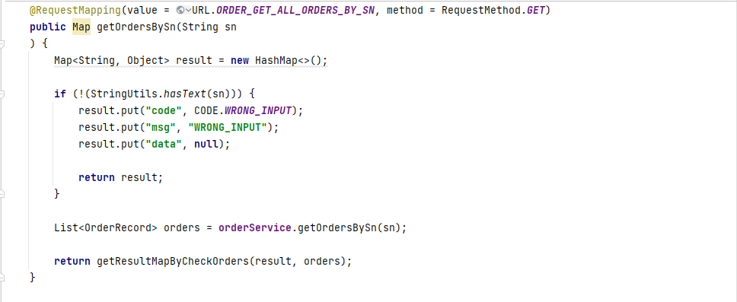

***Figure Appendix D.3.1.7: getOrdersBySn***

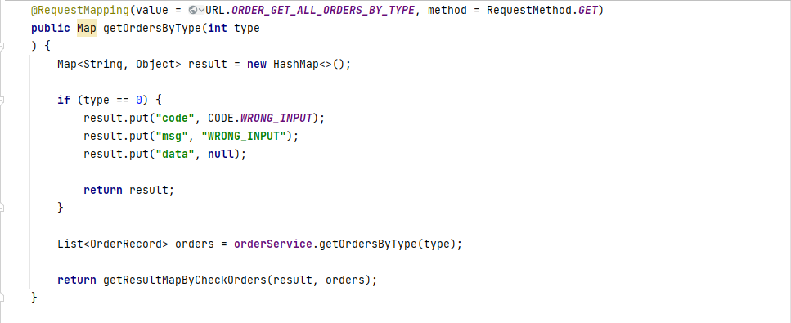

***Figure Appendix D.3.1.8: getOrderByType***

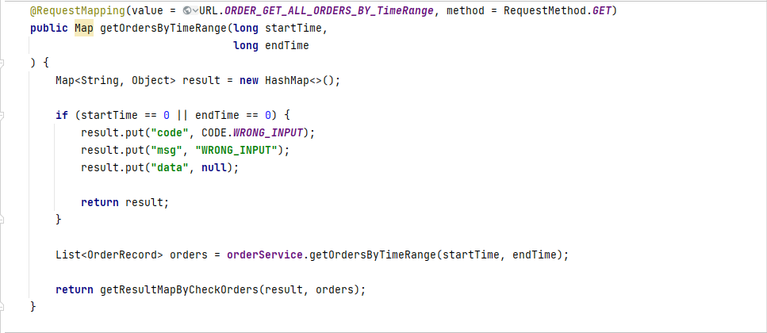

***Figure Appendix D.3.1.9: getOrdersByTimeRange***

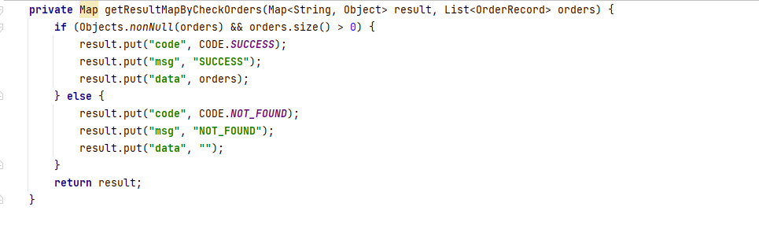

***Figure Appendix D.3.1.10: getResultMapByCheckOrders_List<OrderRecord>***

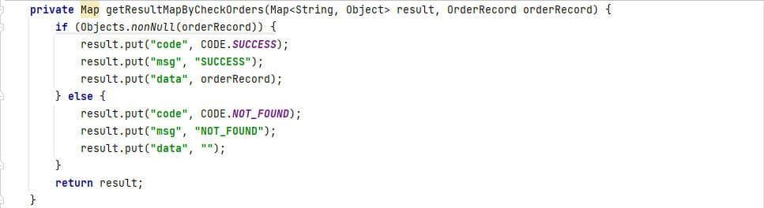

***Figure Appendix D.3.1.11: getResultMapByCheckOrders_OrderRecord***

* 1. Service

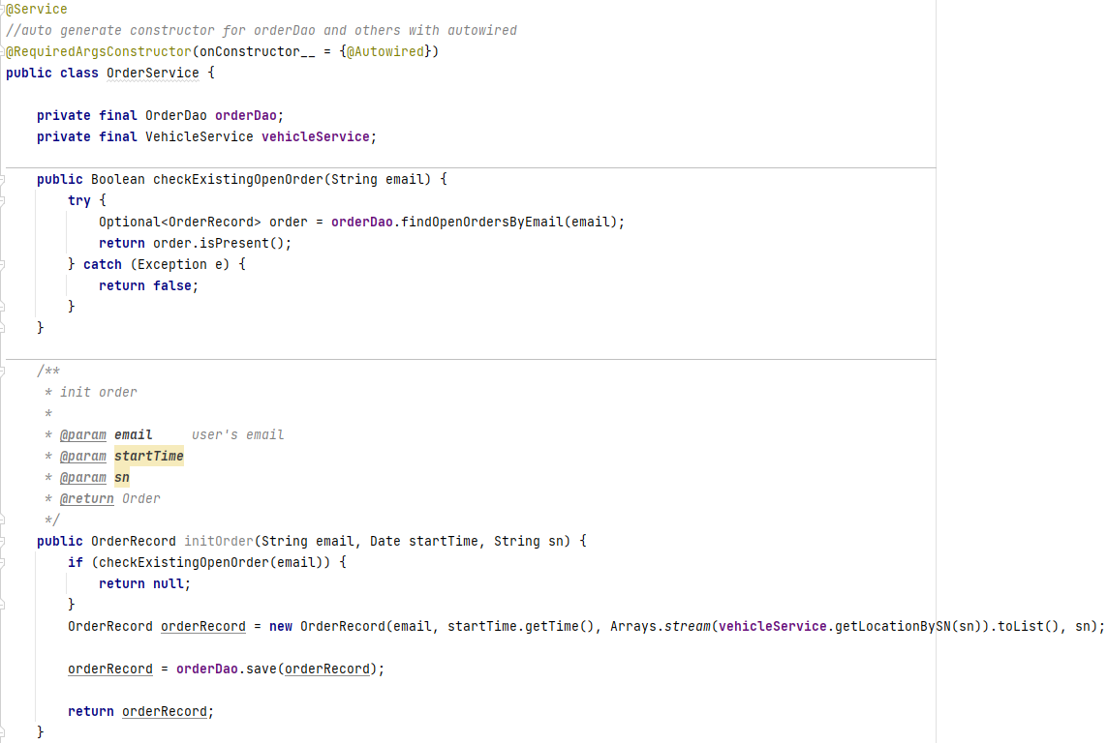

***Figure Appendix D.3.2.1: orderService(1)***

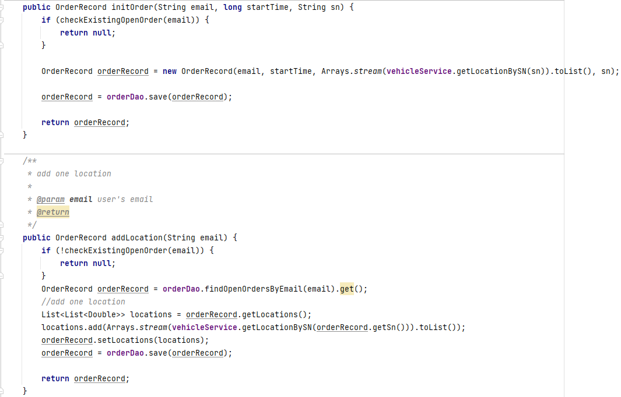

***Figure Appendix D.3.2.2: orderService(2)***

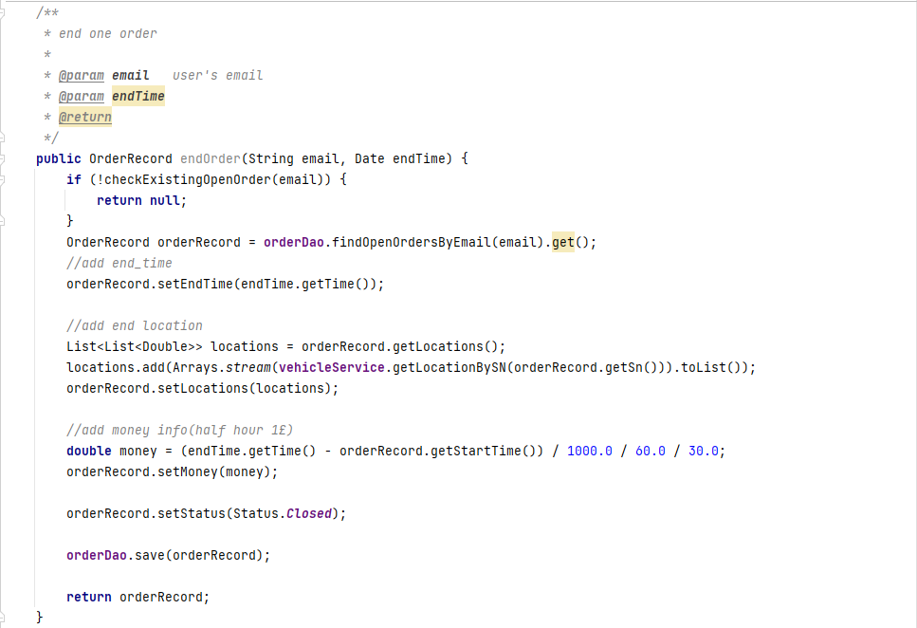

***Figure Appendix D.3.2.3: orderService(3)***

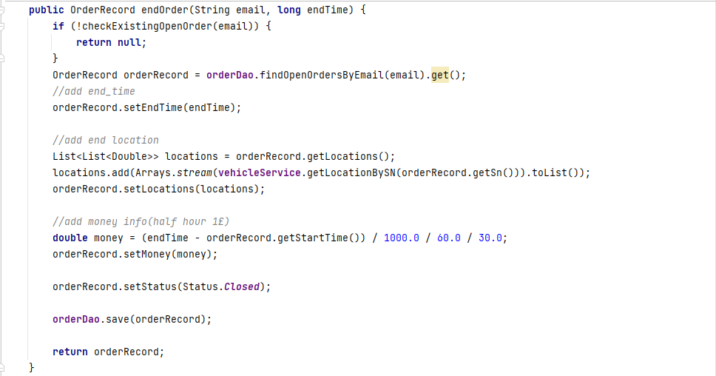

***Figure Appendix D.3.2.4: orderService(4)***

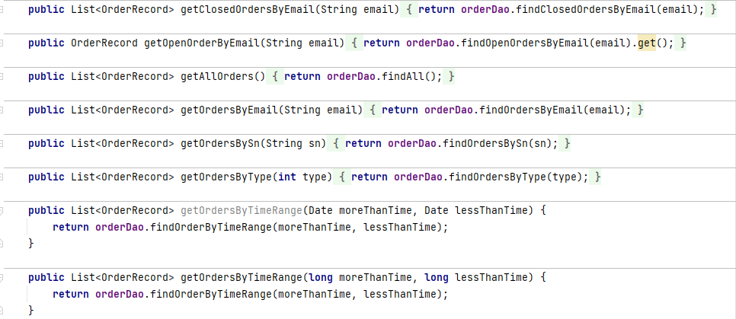

***Figure Appendix D.3.2.5: orderService(5)***

* 1. Dao

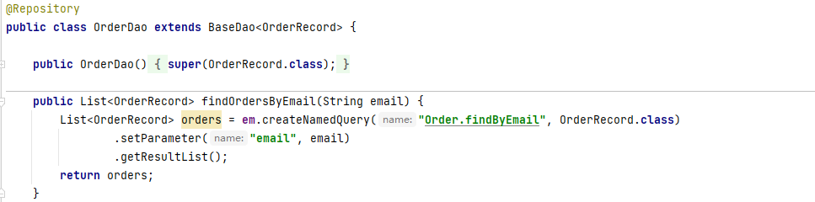

***Figure Appendix D.3.3.1: orderDao(1)***

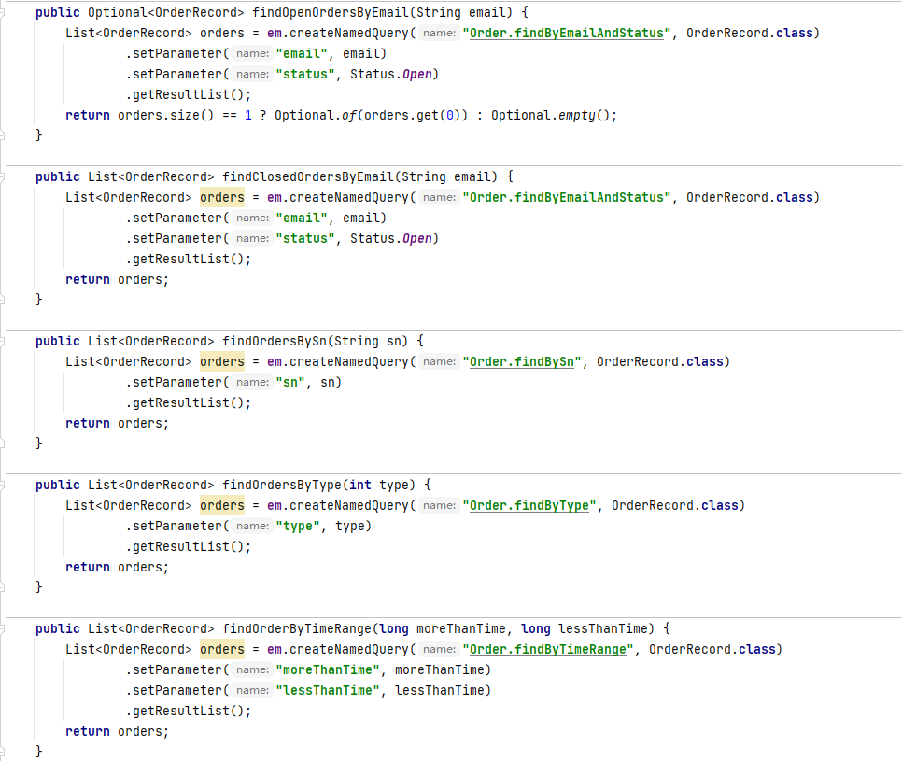

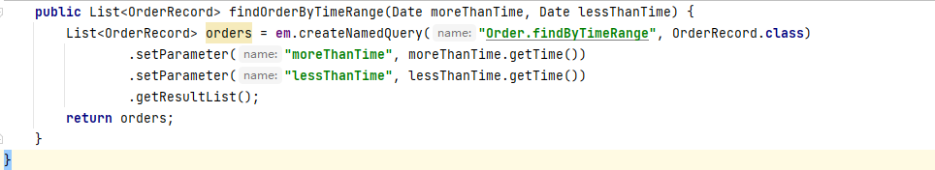

***Figure Appendix D.3.3.2: orderDao(***

1. Ticket
   1. Controller

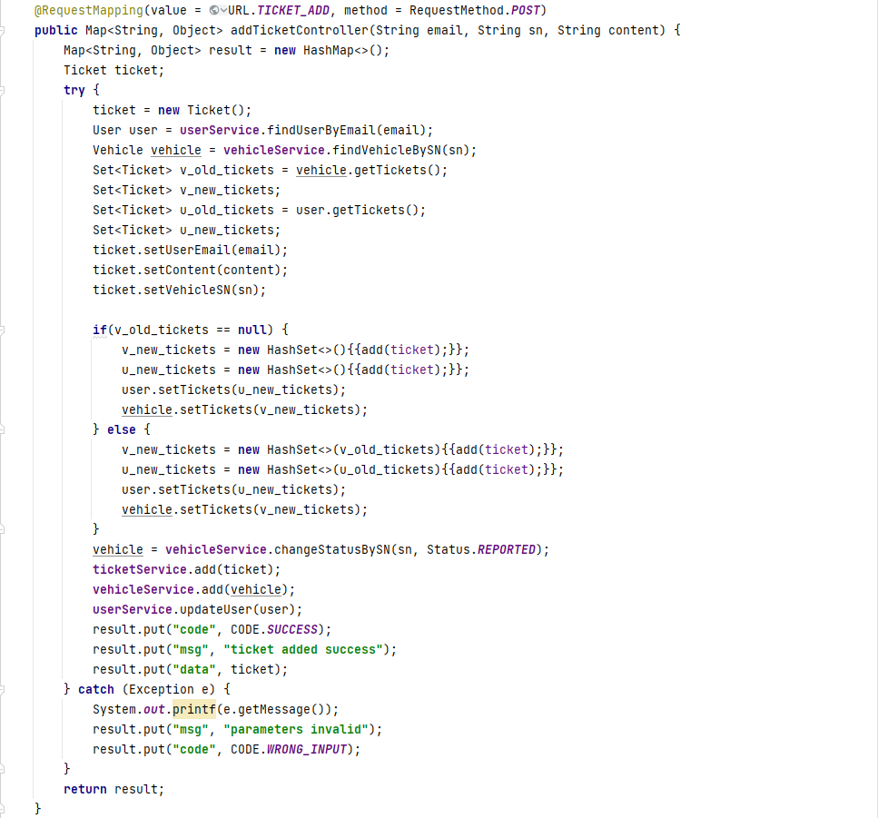

***Figure Appendix D.4.1.1: addTicketController***

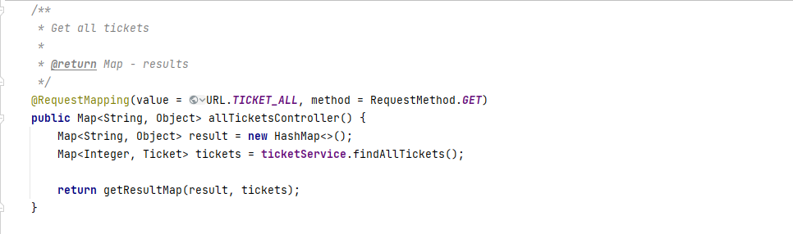

***Figure Appendix D.4.1.2: allTicketController***

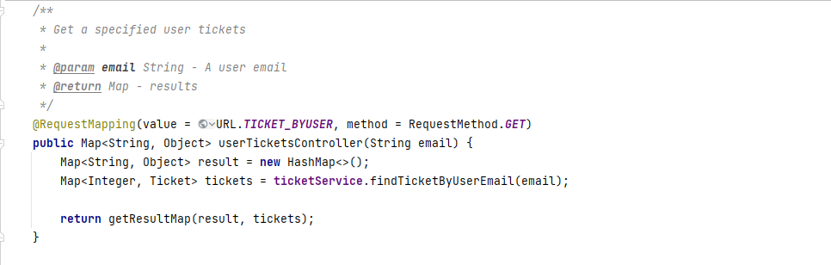

***Figure Appendix D.4.1.3: userTicketsController***

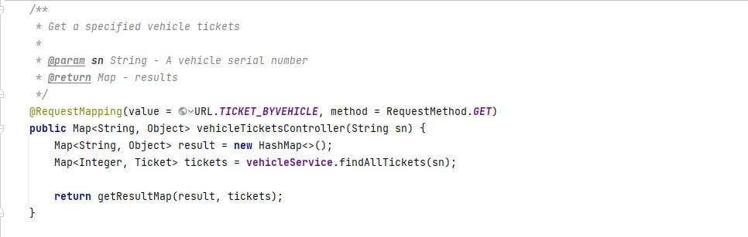

***Figure Appendix D.4.1.4: vehicleTicketsController***

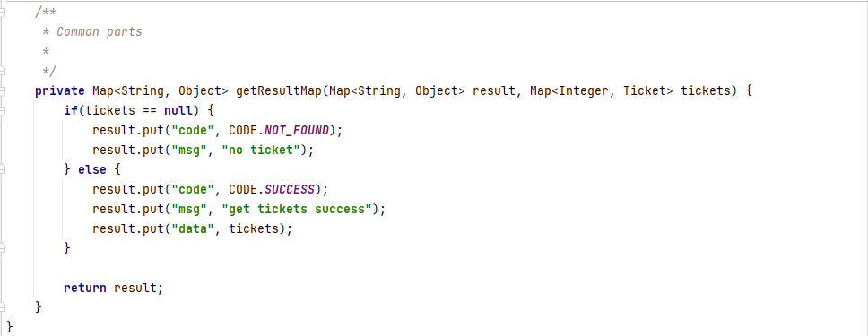

***Figure Appendix D.4.1.5: getResultMapController***

* 1. Service

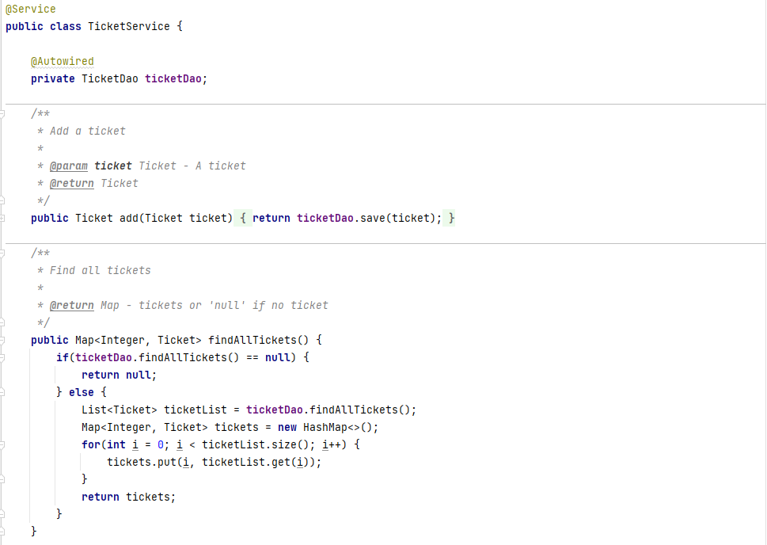

***Figure Appendix D.4.2.1: ticketService(1)***

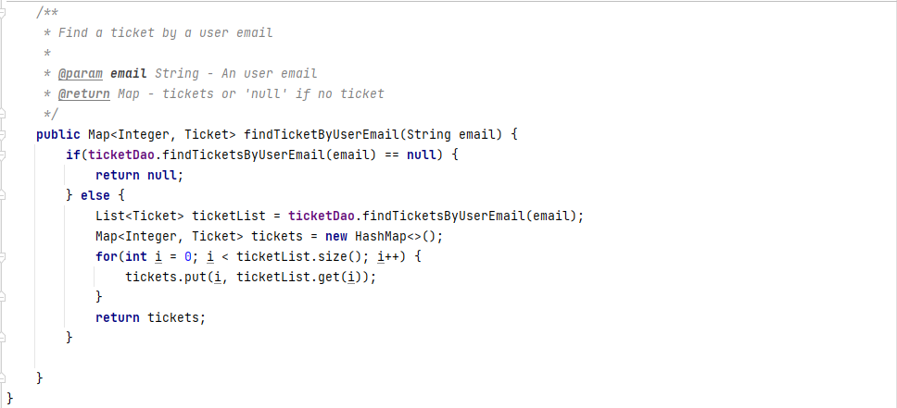

***Figure Appendix D.4.2.2: ticketService(2)***

* 1. Dao

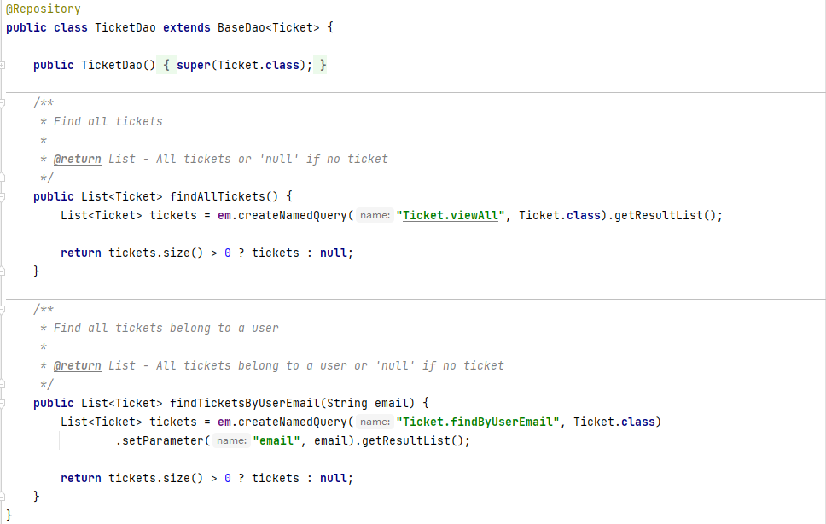

***Figure Appendix D.4.3.1: ticketDao***

1. Balance
   1. Controller

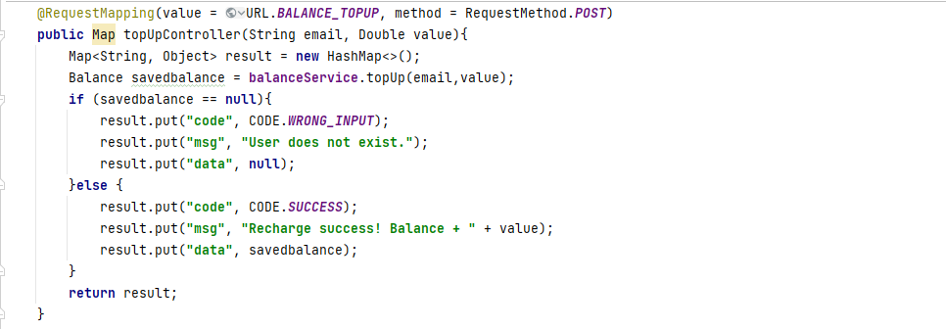

***Figure Appendix D.5.1.1: topUpController***

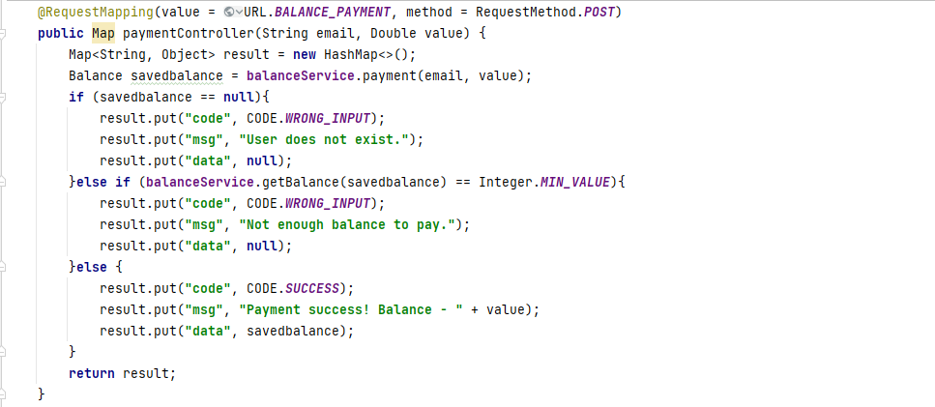

***Figure Appendix D.5.1.2: paymentController***

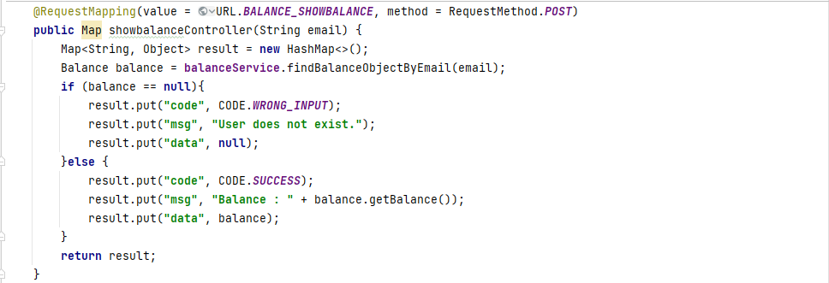

***Figure Appendix D.5.1.3: showbalanceController***

* 1. Service

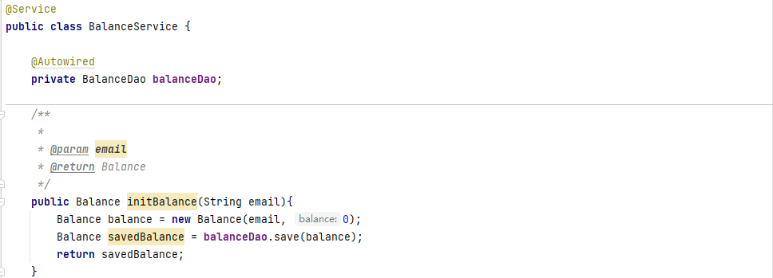

***Figure Appendix D.5.2.1: balanceService(1)***

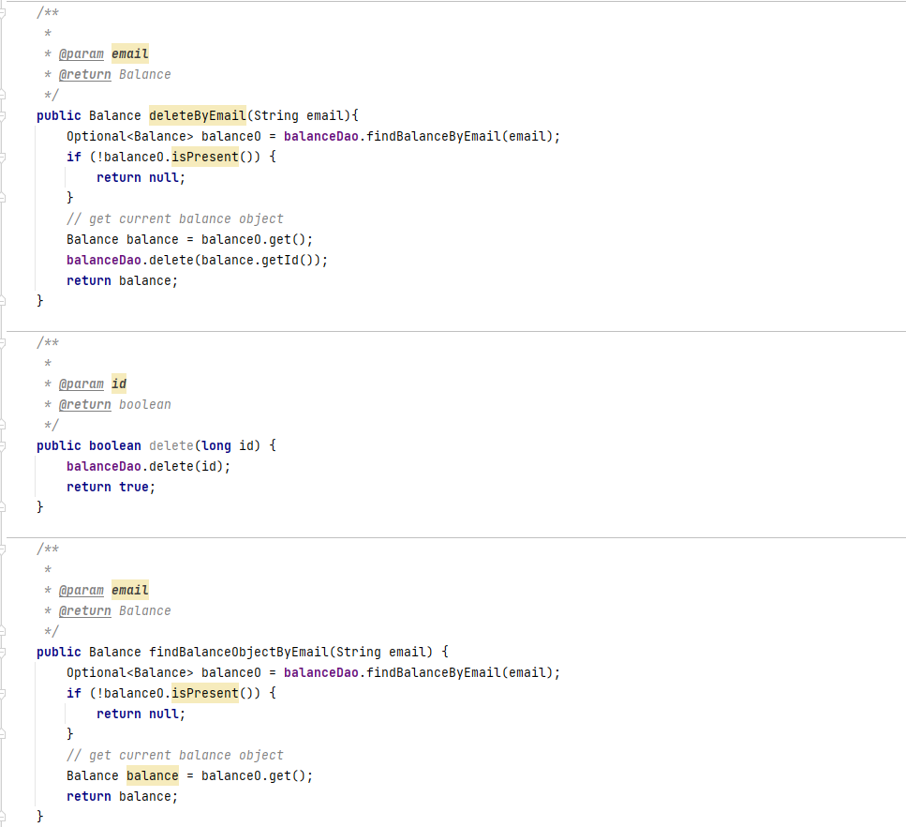

***Figure Appendix D.5.2.2: balanceService(2)***

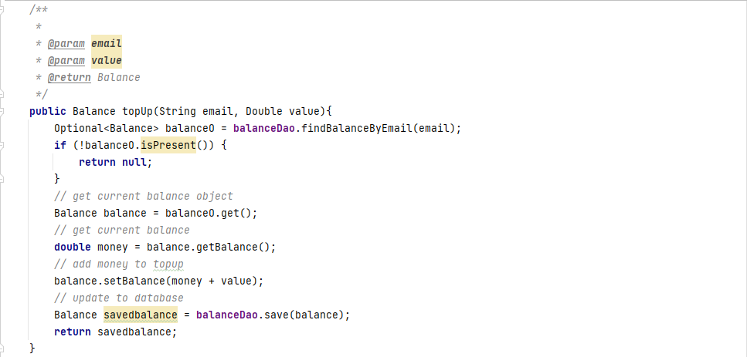

***Figure Appendix D.5.2.3: balanceService(3)***

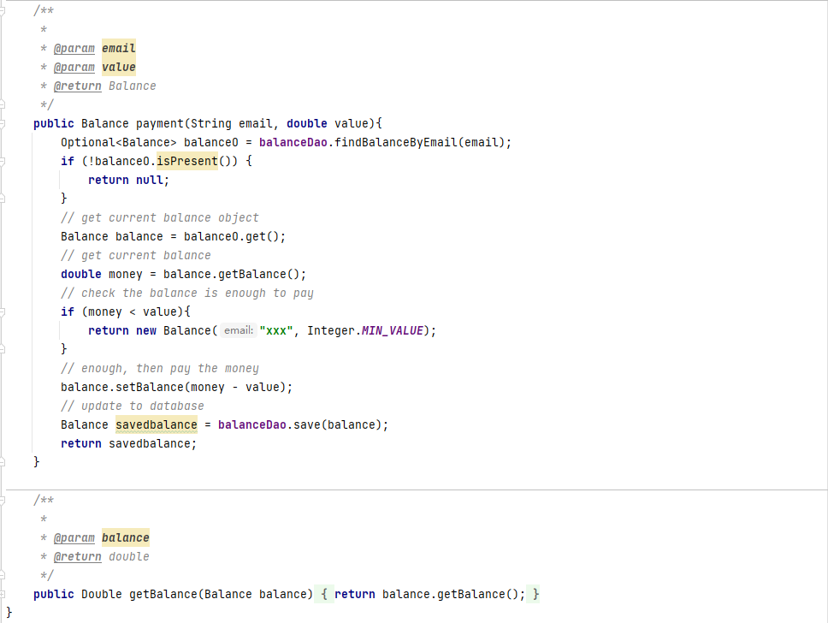

***Figure Appendix D.5.2.4: balanceService(4)***

* 1. Dao

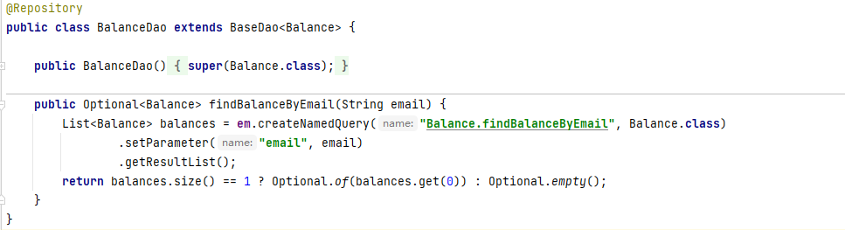

***Figure Appendix D.5.3.1: balanceDao***

###### < Front-end code showcase >

***1 manager***

***1.1 Layout***

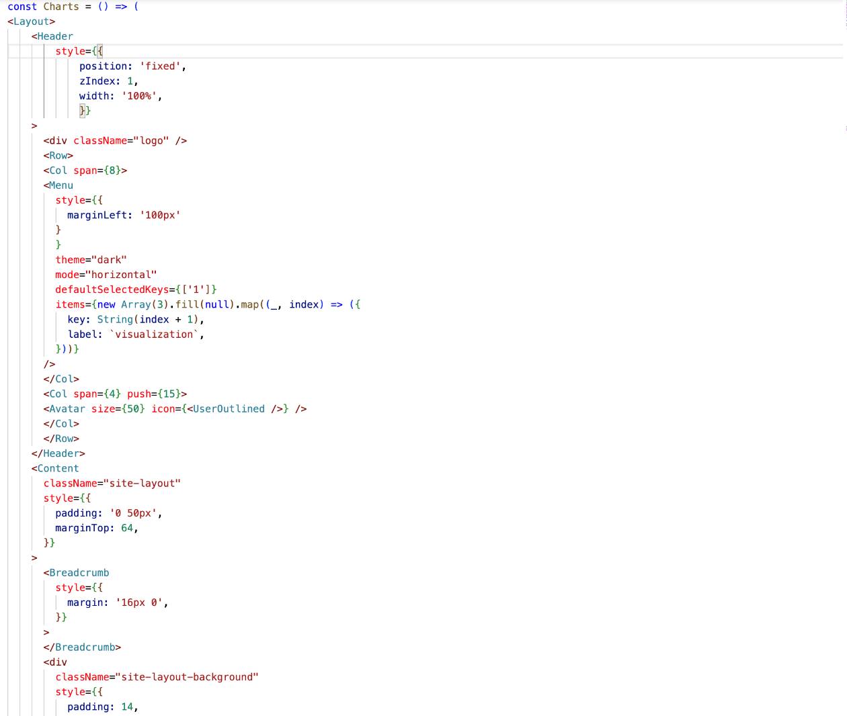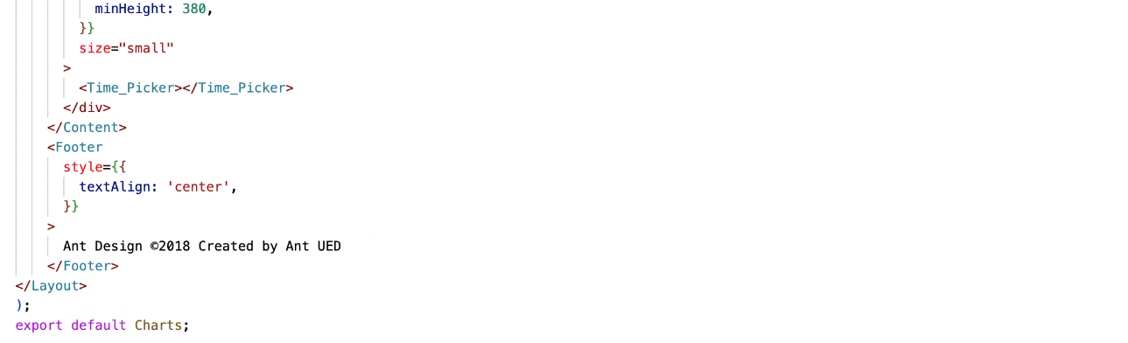Figure Appendix E.1.1 charts/index.jsx

###### < User Roles & User stories >

Considering the need to refine more, we have developed some scenarios to capture the following scenarios rental car users, administrators, and operators with different needs of three subjects, users from different age ranges and different occupations that will interact with the application. For users using shared motor vehicles, the following scenarios have one main goal, to pay and rent a motor vehicle to ride and finally complete the return operation, and these specific operations will be implemented in the developed application. Detailed scenarios can be viewed in the appendix.

bob is a 35-year-old employee of a company in Glasgow. He lives in an apartment in the G11 area of Glasgow with his wife and two children. His company is located in Glasgow city center and he uses the subway for his daily commute. However, bob has recently developed some health problems and his doctor has advised him to do more exercise, but bob's busy schedule and the need to help look after his two children rarely leaves him enough time for exercise, so cycling to and from work has become his preferred option.

Jane is a 32-year-old lawyer who works in a Glasgow law firm, but she lives almost 20 minutes away from her workplace. As a lawyer she works a lot of hours every day, and she often feels very tired at the end of the day, but has to walk home. So she needed a car rental app that would allow her to get back to her home quickly and easily by renting a shared motor vehicle.

John is a graduate student at the University of Glasgow and has a lot of offline classes during the semester with short intervals between classes, so he needs to move quickly from one building to another in a short period of time. Due to the undulating terrain of the university, he has to go uphill and downhill all the time, which consumes a lot of time on the road, so the shared electric bike is a great option for John, as he can easily get between the two buildings in a few minutes' ride and easily prepare for his next class.

Lisa and Mona are good friends whose families live together and also often meet on weekends to walk to the city center, three kilometers from their home, to do some shopping, usually buying some clothes and cosmetics in the city center before the two walk home with their respective shopping bags. But on their way home, they saw a shared bicycle, so they decided to give this a try. They put their shopping bags in front of the bicycle and easily returned home within 15 minutes, which also greatly reduced their tiredness after shopping. So for them, having bikes on the roadside that they can see and use makes their lives easier.

Whittaker, a high school student in Edinburgh, was on his way out of class when he noticed cyclists riding brightly colored bikes that he had never seen before and found very new. He made a mental note of this look-alike and learned on the Internet that it was a shared bike. A few days later, on Whittaker's way home from class, he saw the bike again on the street. This time he decided to try it himself, and after a prompt on the bike, he downloaded the bike-sharing app on his phone and rode home easily after some operations.

Bobby is a 32-year-old doctor who works at a general hospital in Newcastle, but the distance between her place of work and her place of residence requires her to use the subway. But there is still some distance between the subway and her home. Therefore, she needs a car rental app that will allow her to get back to her home more quickly and easily by renting a shared motor vehicle.

**Car rental users**

The first thing consumers want to see when they access the car rental app

- As a car rental user, I want to see the different types of vehicles available in all areas to make sure I can find the vehicle closest to me.

- As a rental car user, I want to be able to top up my wallet so that I don't need to pay for every ride.

- As a rental car user, I would like to have a way to report problem vehicles

- As a rental car user, I want to be able to register/login so that I have more functionality.

- As a car rental user, I want to be able to access my previous orders so I can determine the cost of a specific route and have an easier time processing future orders.

- As a car rental user, I would like to have a cancellation option so that I can return the car early if I don't want to use it.

- As a rental car user, I would like to have the option to park temporarily so that if I need to leave the car for a short time I can continue to use it when I return.

**Operator User**

- As an operator, I would like to be able to register/login so that I have more functionality.

- As an operator, I would like to be able to view all vehicle information as well as view specific information about damaged vehicles

- As an operator, I would like to be able to update vehicle information, such as updating vehicle location and updating vehicle health

- As an operator, I would like to be able to view vehicle rental information

- As an operator, I would like to be able to create and delete vehicle information

**Manager Users**

- As a manager, I would like to be able to view all user information, view all order records, and generate reports.

###### < User Module >

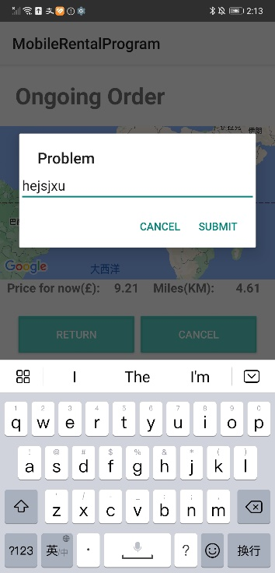

Figure Appendix G.1.1 problem submit

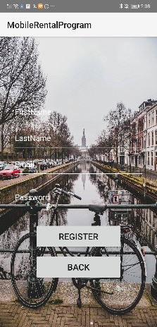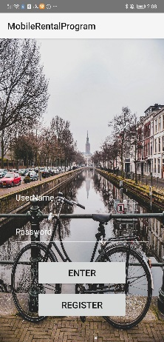

Figure Appendix G.1.2 register & Log in

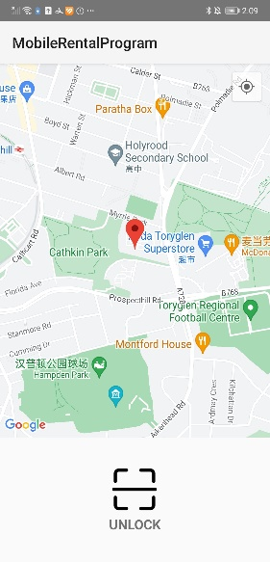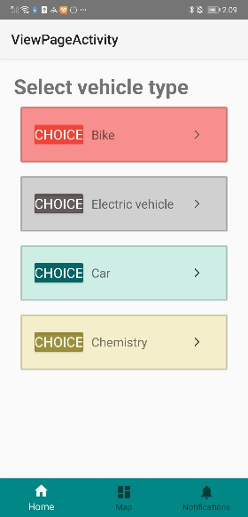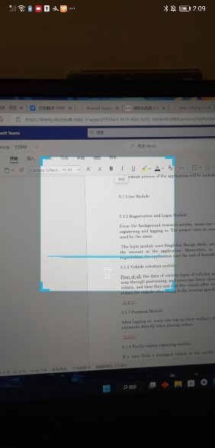

Figure Appendix G.1.3 view map & choose vehicle

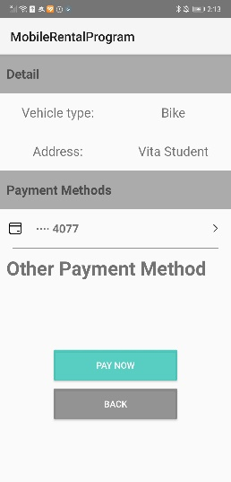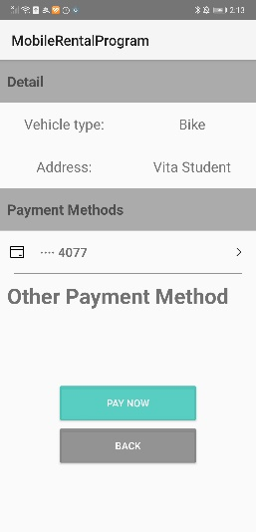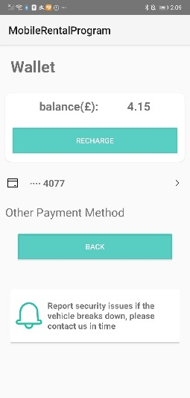

Figure Appendix G.1.4 payment & wallet

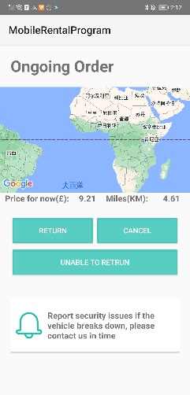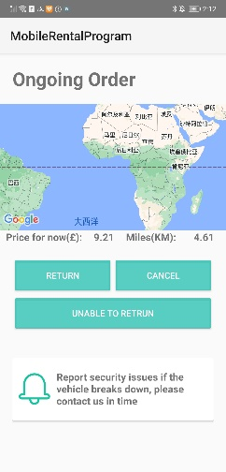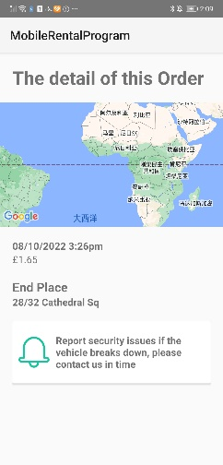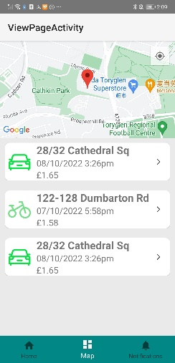

Figure Appendix G.1.5 Order

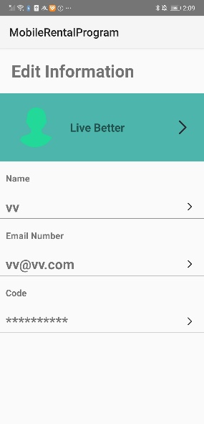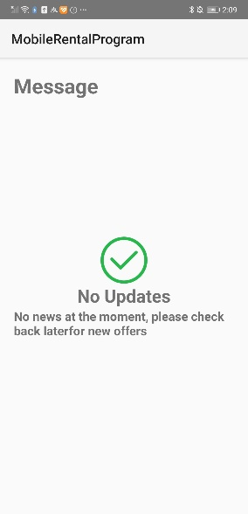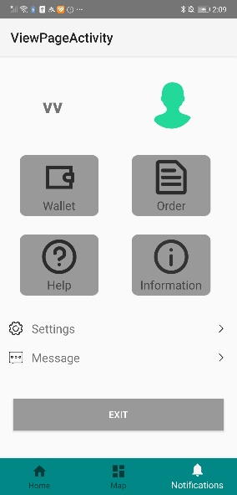

Figure Appendix G.1.6 information

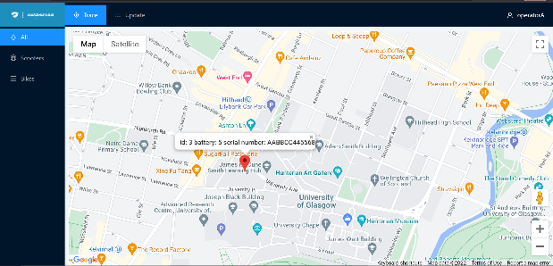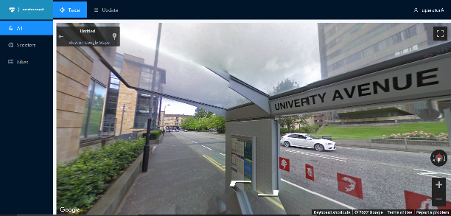

Figure Appendix G.1.7 google map

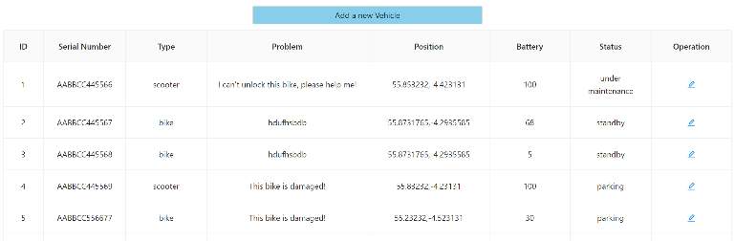 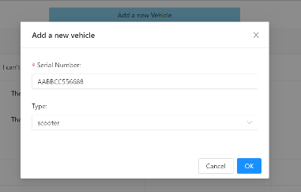

Figure Appendix G.1.8 View Information Module

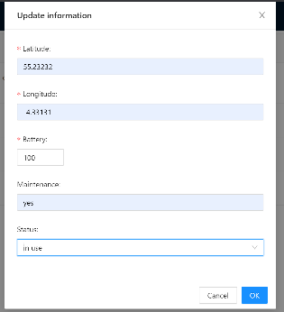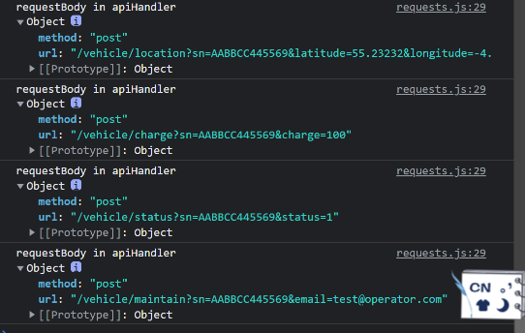

Figure Appendix G.1.9 Update Information Module